CDS Models Workflow Manual
Release edition 18 September 2026
This manual explains which records and model choices supply each calculation in CDS. Follow the workflow from constituents through micromechanics and laminate definition to the applicable load and response. Thermal, moisture and electromagnetic studies have distinct input requirements; a link in the workflow must reflect an actual dependency, not an assumed coupling.

How to use this manual
Read the assumptions before choosing a model. Keep units consistent, inspect solver notices and use the recorded checks to distinguish a completed calculation from a validated result. Chapter links lead to the interactive website; exercise links open the Workbench. Account-controlled database downloads and classroom materials remain subject to their existing access rules.
Equations are editable Word mathematics. This PDF is exported from the same Word document. Historical reference chapters retain their stated scope; the current workflow and exercise chapters describe the available CDS implementation.

Contents
1 Fully integrated Micro to Macro Engineering.
2 Turn model output into repeatable engineering evidence.
3 Connect engineering work through the CDS cloud.
4 Evaluate the complete composite structure.
5 Turn ply definitions into laminate decisions.
6 Build a trusted materials foundation.
7 Translate constituents into effective material behavior.
8 Models you can use. Connections you can follow.
9 Connect design intent to process behavior.

1 Fully integrated Micro to Macro Engineering
Online chapter
Follow one connected engineering record through materials, micromechanics, laminates, processing, structural design, and the CDS cloud.

Integrated solver hierarchy
Select a colored layer to explore its workflow, or a model box to open its theory. The connected study branches below cover all 42 current model families, including the specialist studies.
Integrated composite solver hierarchy from materials and Cox elastic micromechanics through CLT, FSDT, cylinder mechanics, LaRC04, cohesive delamination and separate fatigue assessment — part 1 of 2
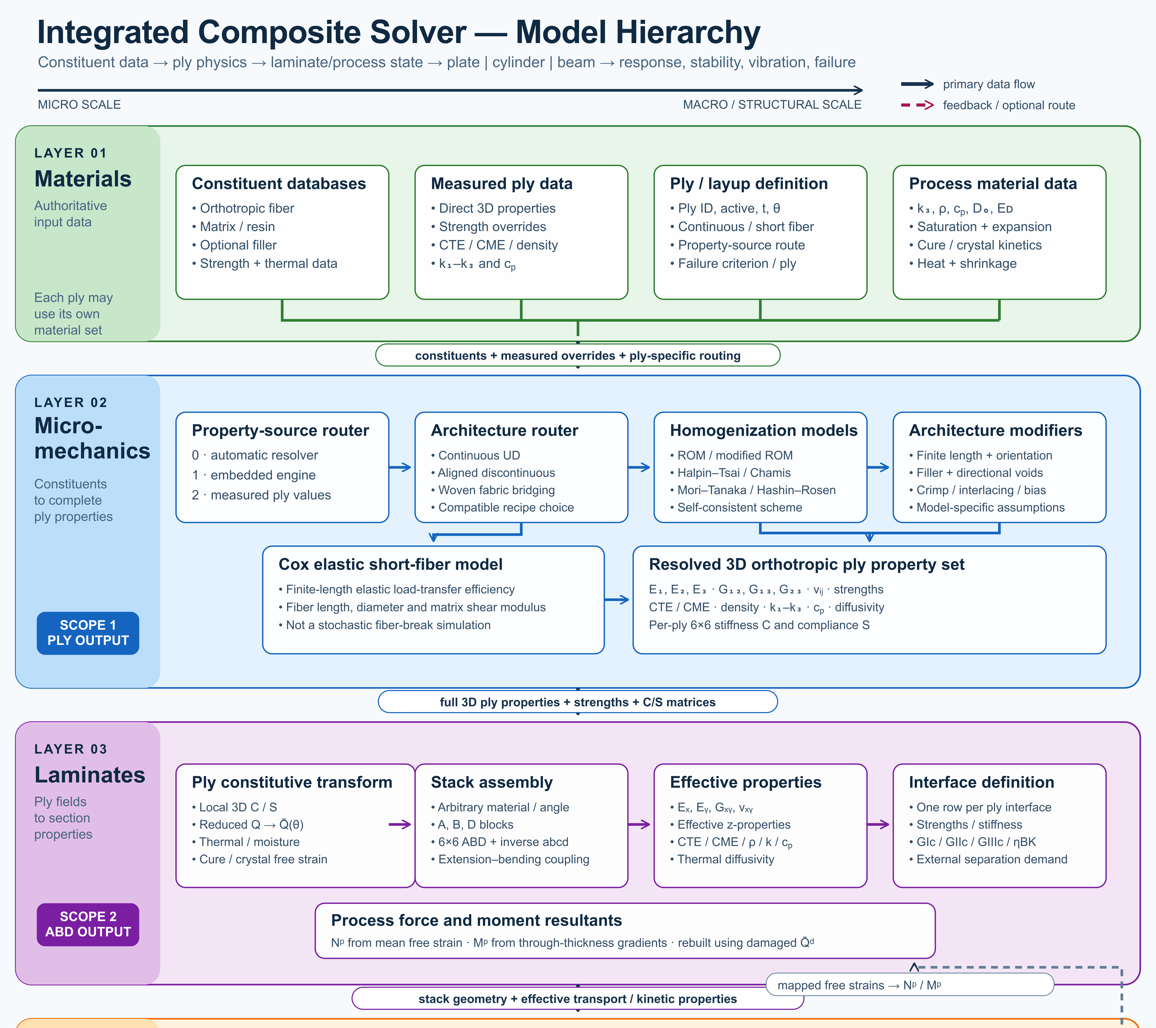
Integrated composite solver hierarchy from materials and Cox elastic micromechanics through CLT, FSDT, cylinder mechanics, LaRC04, cohesive delamination and separate fatigue assessment — part 2 of 2
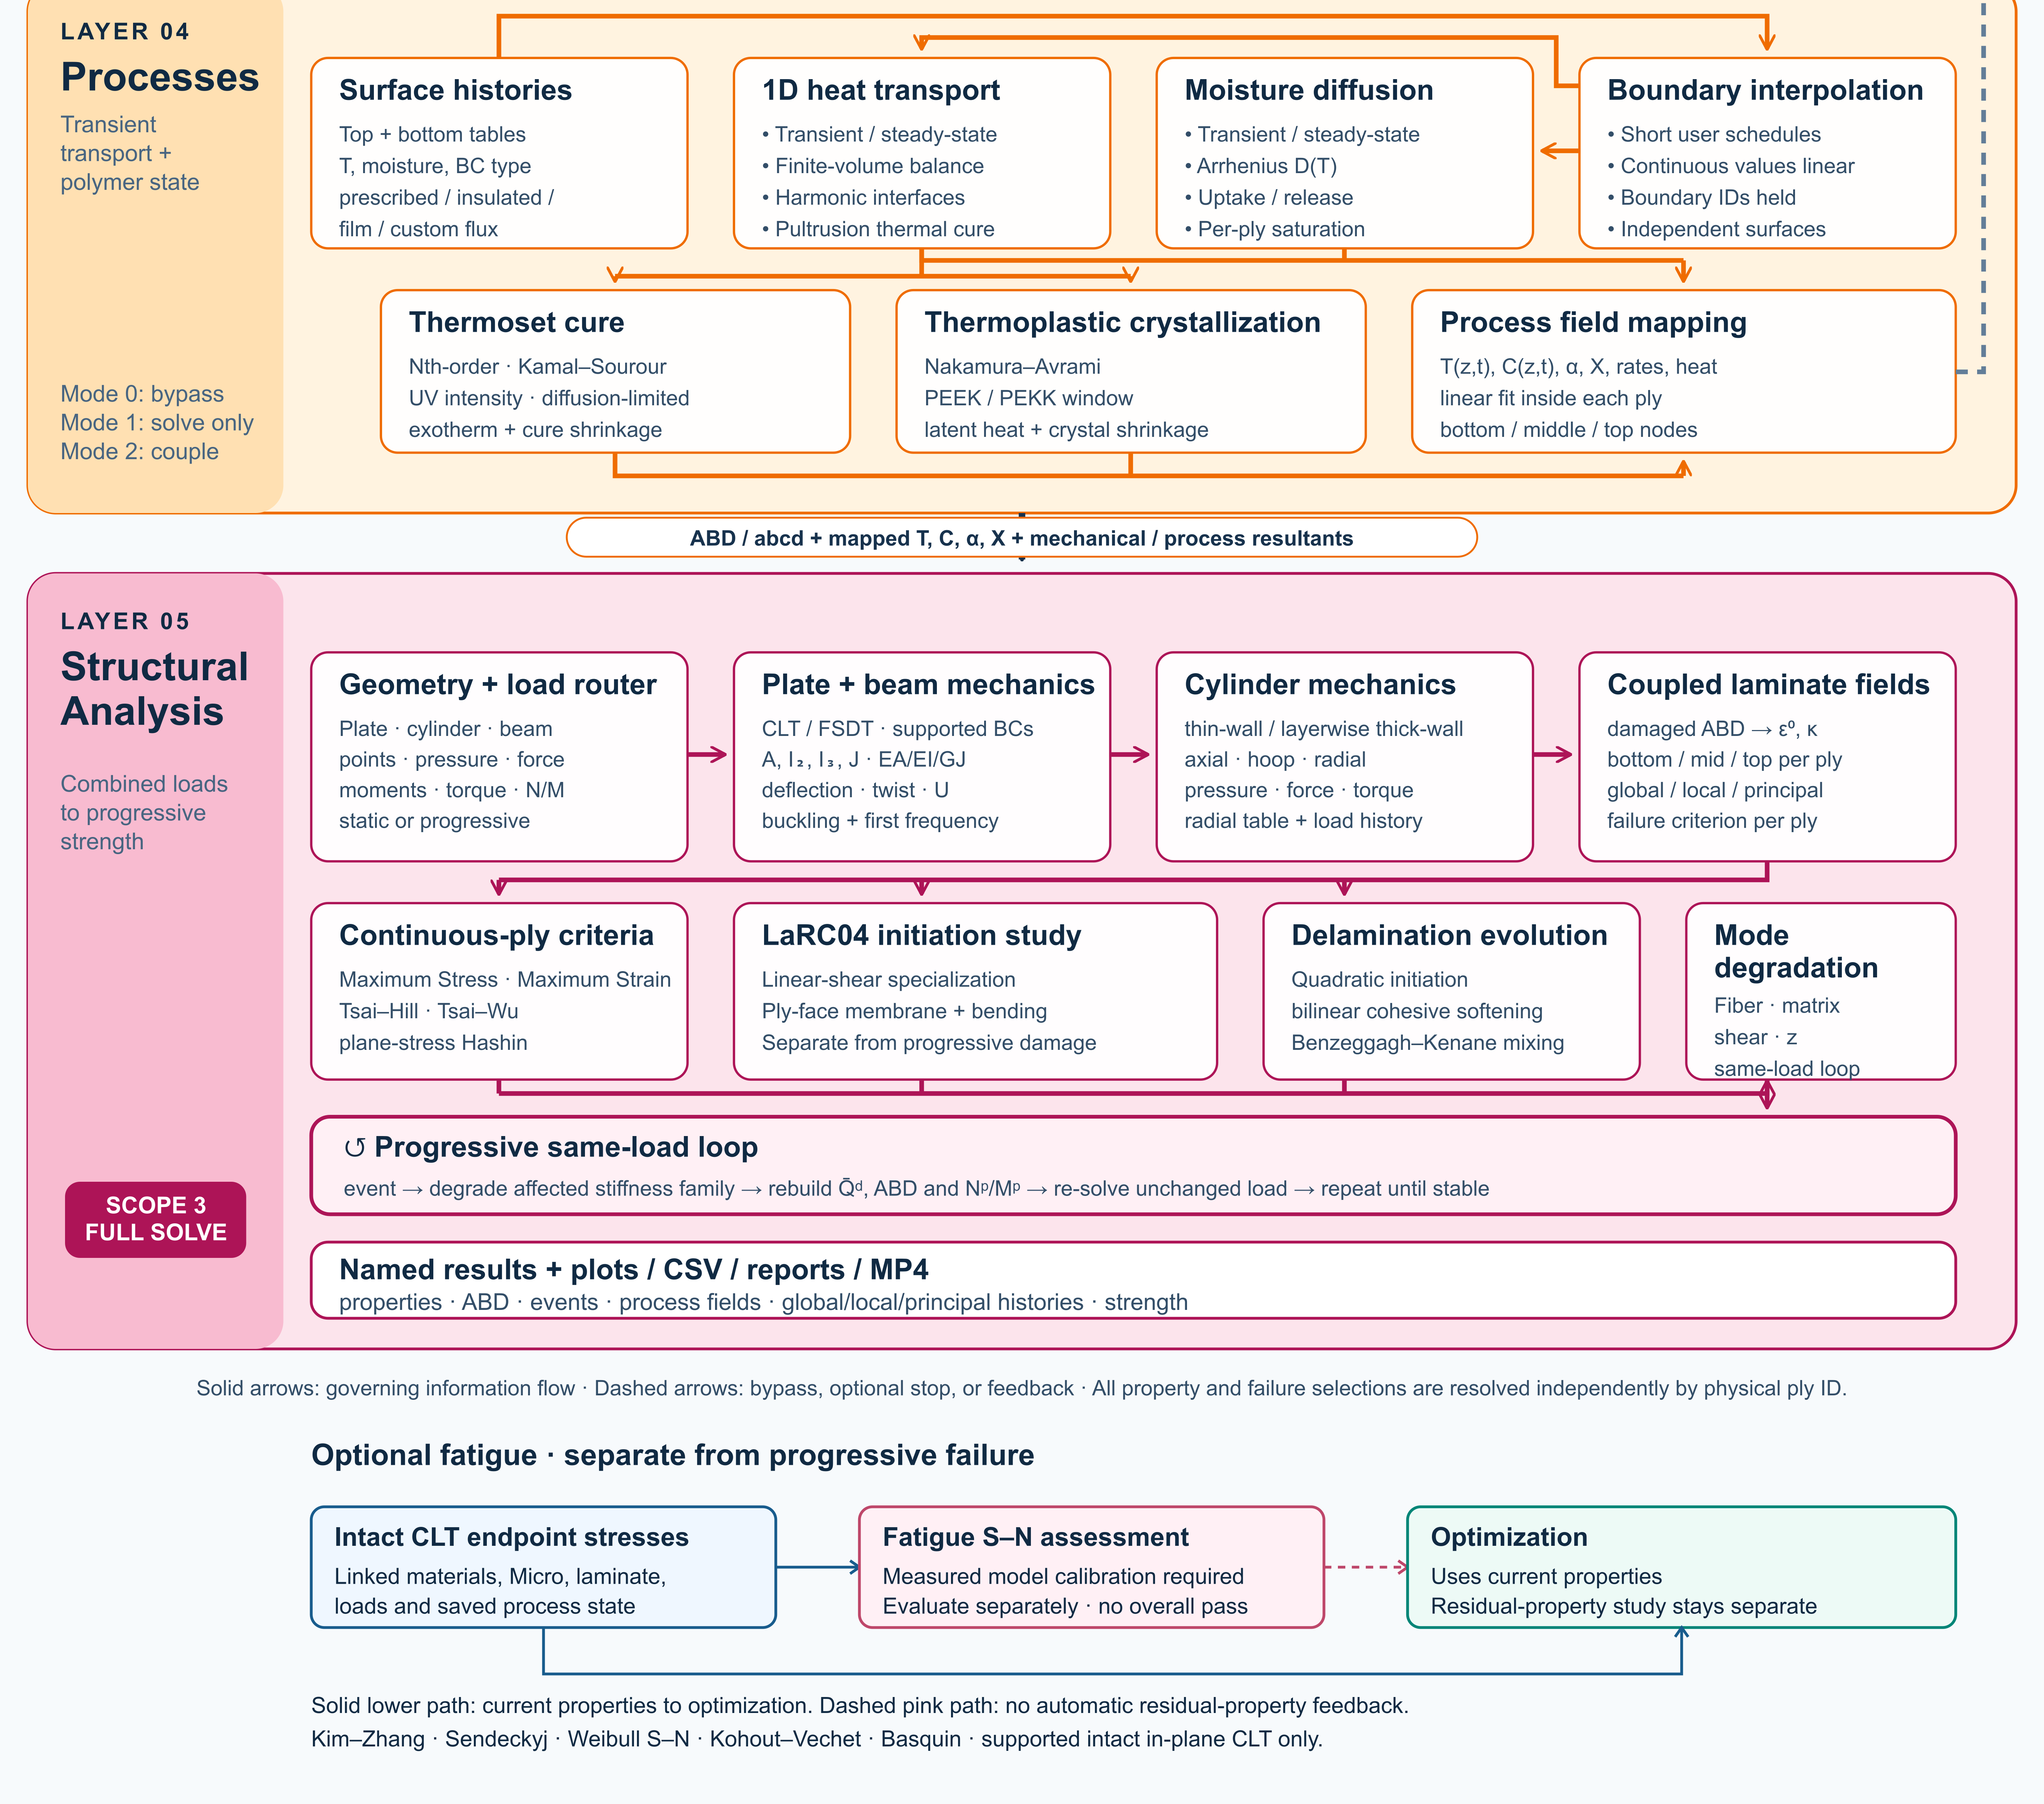
Each branch has its own compatible inputs and assumptions—not every model runs in one simulation. Fatigue S–N and calibrated residual-property studies are separate from progressive failure; neither automatically changes the saved laminate or optimization properties. ∑ Fatigue theory .

Connected model branches
Micromechanics · 9
Input ↓ Constituents, architecture, fractions and calibrated modifiers Result ↓ Reference ply properties for each linked laminate ply
- Halpin–Tsai
- Rule of mixtures
- Modified rule of mixtures
- Chamis
- Mori–Tanaka
- Hashin–Rosen
- Self-consistent scheme
- Woven fabric bridging
- Cox shear-lag elastic
One compatible homogenization model per Micro recipe. Use separate recipes for comparisons; they are not combined in a single ply.
∑ Theory & limits
Exercise
Cure, crystallization & material transport · 8
Input ↓ Calibrated kinetics, modulus or transport laws and material assignment Result ↓ Material laws consumed by compatible Micro or transport calculations
- Kamal–Sourour autocatalytic
- Kamal–Sourour with diffusion control
- Nth-order Arrhenius
- CHILE (degree of cure)
- UV intensity-dependent cure
- Nakamura–Avrami
- Temperature-dependent tabular
- 1D Fickian diffusion
Independent model records can be linked together through material inputs. A saved model must be assigned to a material before it contributes to a simulation.
∑ Theory & limits
Exercise
Thermal transport · 3
Input ↓ Laminate transport properties, initial state and the thermal case’s own surface cycle Result ↓ Temperature and supported polymer-state histories; mapped fields only when coupling is enabled
- 1D transient heat transfer
- 1D steady-state heat transfer
- 1D pultrusion thermal cure
One transport formulation per thermal case. Select its laminate and configure its own initial conditions and surface cycle; pultrusion additionally requires a distance-based die schedule and pulling velocity.
∑ Theory & limits
Exercise
Moisture transport · 2
Input ↓ Laminate diffusion properties, initial moisture and its own boundary schedule Result ↓ Moisture history and enabled swelling contribution
- 1D transient moisture diffusion
- 1D steady-state moisture diffusion
One formulation per moisture analysis. Thermal and moisture analyses can both be linked in Simulation; each needs its own boundary conditions.
∑ Theory & limits
Exercise
Plate · CLT & FSDT · 6
Input ↓ Laminate stiffness, finite plate dimensions, supported edges and study choice Result ↓ FSDT static bending or selected buckling / modal results; not progressive damage
- CLT
- FSDT
- Static bending
- Modal
- Buckling
- Buckling and modal
Choose a formulation and study. Buckling and modal can be requested together; static bending requires FSDT. These are reference-elastic studies, separate from coupled process or progressive failure.
∑ Theory & limits
Exercise
Cylinder · 2
Input ↓ Laminate, cylinder dimensions and formulation-compatible pressure / axial loading Result ↓ Thin-wall membrane response or layerwise radial fields, with distinct assumptions
- Linear thin-wall membrane
- Layerwise thick-wall elasticity
Choose one cylinder formulation per case record. Geometry and plies remain shared; thick-wall radial results exclude torsion and process strains.
∑ Theory & limits
Exercise
Membrane, bending & beam buckling · 3
Input ↓ Laminate, compatible section and static or Euler load case Result ↓ Membrane / bending response or separate Euler buckling result
- Linear static
- Linear static with failure indices
- Beam Euler buckling
Geometry and the case determine the membrane or beam-test interpretation. Euler buckling requires a compatible beam section and a separate reference-elastic study; it is not a strength or local-buckling pass.
∑ Theory & limits
Exercise
Layerwise sections, joints & delamination · 3
Input ↓ Section or lap geometry, laminate, loads and calibrated interface properties Result ↓ x–z fields; coupled ply damage and delamination only for the supported layerwise plate path
- Layerwise x-z plane strain
- Single-lap x-z plane strain
- Coupled delamination growth
Coupled delamination is available only for the layerwise Plate section and needs calibrated interface and ply properties. Lap-shear uses its separate joint geometry and perfectly bonded elastic formulation.
∑ Theory & limits
Exercise
Sandwich bending · 1
Input ↓ Faces, core, dimensions and three-point-bend load Result ↓ Deflection and separate face, core and nominal bond-shear screening
- Sandwich three-point bend
Dedicated sandwich screening. Check core, faces and nominal bond shear separately; peel, mixed-mode debonding and crack growth are not assessed.
∑ Theory & limits
Exercise
Failure & envelope comparison · 5
Input ↓ Eligible CLT load case, strengths / strain limits and selected criterion Result ↓ First-ply envelopes or supported progressive ply-damage histories; criteria are not blended
- Maximum stress
- Maximum strain
- Tsai–Hill
- Tsai–Wu
- Hashin
One primary failure criterion per load. In Response → Failure, compare all eligible theories or a custom selection in the envelope controls. Each theory runs independently; criteria are not blended.
∑ Theory & limits
Exercise
Fatigue S–N · 5
Input ↓ Intact ply stresses, cyclic loads and measured S–N calibration Result ↓ Separate life assessment; no automatic laminate degradation
- Kim–Zhang
- Sendeckyj
- Weibull S–N
- Kohout–Vechet
- Basquin
Select calibrated S–N curves for each material, direction and stress sign in Fatigue. Different sources can use different models. S–N life does not define residual stiffness or strength.
∑ Theory & limits
Exercise
D6641 · Compression coupon · 1
Input ↓ Linked laminate and explicit specimen, load or measured calibration inputs Result ↓ Uniform small-strain compression using linked laminate Ex and thickness. Measured compressive strength supplies a screening ratio; fixture, tabs, buckling and failure evolution are not simulated.
- Virtual test · compression coupon
Uniform small-strain compression using linked laminate Ex and thickness. Measured compressive strength supplies a screening ratio; fixture, tabs, buckling and failure evolution are not simulated.
∑ Theory & limits
Exercise
D5379 / D7078 · Shear coupon · 1
Input ↓ Linked laminate and explicit specimen, load or measured calibration inputs Result ↓ Uniform nominal shear between notches using linked laminate Gxy and thickness. Not a notch/fixture stress field or nonlinear shear solution. Gauge length is the effective shear deformation length, not crosshead travel.
- Virtual test · nominal shear coupon
Uniform nominal shear between notches using linked laminate Gxy and thickness. Not a notch/fixture stress field or nonlinear shear solution. Gauge length is the effective shear deformation length, not crosshead travel.
∑ Theory & limits
Exercise
D5528 · DCB opening · 1
Input ↓ Linked laminate and explicit specimen, load or measured calibration inputs Result ↓ Ideal Euler–Bernoulli DCB with equal homogeneous 0° arms, each half the linked laminate thickness. No root rotation, shear, large displacement or cohesive growth. Critical load is an initiation estimate from supplied GIc.
- Virtual test · DCB beam compliance
Ideal Euler–Bernoulli DCB with equal homogeneous 0° arms, each half the linked laminate thickness. No root rotation, shear, large displacement or cohesive growth. Critical load is an initiation estimate from supplied GIc.
∑ Theory & limits
Exercise
D7905 · ENF sliding · 1
Input ↓ Linked laminate and explicit specimen, load or measured calibration inputs Result ↓ Ideal equal-arm, homogeneous 0° ENF beam; support span is twice the half-span. Crack must be shorter than the half-span. No shear/root correction or unstable crack growth. GIIc is supplied, not fitted automatically.
- Virtual test · ENF beam compliance
Ideal equal-arm, homogeneous 0° ENF beam; support span is twice the half-span. Crack must be shorter than the half-span. No shear/root correction or unstable crack growth. GIIc is supplied, not fitted automatically.
∑ Theory & limits
Exercise
D6671 · Mixed-mode fracture envelope · 1
Input ↓ Linked laminate and explicit specimen, load or measured calibration inputs Result ↓ Benzeggagh–Kenane envelope from calibrated GIc, GIIc and exponent. Supplied GI/GII are energy-release rates from a separate test reduction or analysis. This does not resolve the MMB lever fixture or propagate a crack.
- Virtual test · BK mixed-mode envelope
Benzeggagh–Kenane envelope from calibrated GIc, GIIc and exponent. Supplied GI/GII are energy-release rates from a separate test reduction or analysis. This does not resolve the MMB lever fixture or propagate a crack.
∑ Theory & limits
Exercise
D5229 · Moisture uptake calibration · 1
Input ↓ Linked laminate and explicit specimen, load or measured calibration inputs Result ↓ Homogeneous slab, initially dry, both faces held at equilibrium moisture. Fits diffusivity from two early uptake measurements (both ≤50% saturation) using the square-root-time approximation. Edge ingress and temperature dependence are excluded. Does not overwrite material properties.
- Virtual test · Fickian uptake calibration
Homogeneous slab, initially dry, both faces held at equilibrium moisture. Fits diffusivity from two early uptake measurements (both ≤50% saturation) using the square-root-time approximation. Edge ingress and temperature dependence are excluded. Does not overwrite material properties.
∑ Theory & limits
Exercise
D5961 · Bearing / bypass screening · 1
Input ↓ Linked laminate and explicit specimen, load or measured calibration inputs Result ↓ Single-pin nominal bearing, net-section and shear-out checks with independent measured allowables. Bypass tension is added to net-section load only. No contact, bolt preload, load redistribution or validated bearing–bypass interaction envelope.
- Virtual test · bearing bypass screening
Single-pin nominal bearing, net-section and shear-out checks with independent measured allowables. Bypass tension is added to net-section load only. No contact, bolt preload, load redistribution or validated bearing–bypass interaction envelope.
∑ Theory & limits
Exercise
D6484 · Open-hole compression · 1
Input ↓ Linked laminate and explicit specimen, load or measured calibration inputs Result ↓ Nominal gross/net stress and demand relative to measured open-hole compressive strength for this geometry and layup. This is test-data screening, not an uncalibrated notch-strength prediction. No local buckling or kink-band simulation.
- Virtual test · measured open-hole compression
Nominal gross/net stress and demand relative to measured open-hole compressive strength for this geometry and layup. This is test-data screening, not an uncalibrated notch-strength prediction. No local buckling or kink-band simulation.
∑ Theory & limits
Exercise
D6742 · Filled-hole comparison · 1
Input ↓ Linked laminate and explicit specimen, load or measured calibration inputs Result ↓ Compares user-measured open- and filled-hole compressive strengths using gross-section stress. Use matched layup, hole, environment and fastener condition. Filling a hole does not automatically recover strength; no fastener contact/preload model is applied.
- Virtual test · measured filled-hole comparison
Compares user-measured open- and filled-hole compressive strengths using gross-section stress. Use matched layup, hole, environment and fastener condition. Filling a hole does not automatically recover strength; no fastener contact/preload model is applied.
∑ Theory & limits
Exercise
D7136 / D7137 · Impact & CAI assessment · 1
Input ↓ Linked laminate and explicit specimen, load or measured calibration inputs Result ↓ Incident energy from measured impact velocity; residual compressive strength from measured peak CAI force. Rebound energy estimates energy not returned to the striker, NOT damage energy. No impact/contact solver, damage-area prediction or energy-to-strength extrapolation.
- Virtual test · measured impact and CAI
Incident energy from measured impact velocity; residual compressive strength from measured peak CAI force. Rebound energy estimates energy not returned to the striker, NOT damage energy. No impact/contact solver, damage-area prediction or energy-to-strength extrapolation.
∑ Theory & limits
Exercise
Open-hole strength · 1
Input ↓ Specially orthotropic laminate, hole radius, unnotched strength and calibrated distances Result ↓ Point / average stress strength screening and radial stress profile
- Whitney–Nuismer open-hole tension
Infinite-width, specially orthotropic tension screening. Point and average stress distances must be calibrated independently for this laminate. Not compression, bearing or a joint allowable.
∑ Theory & limits
Exercise
Creep & stress relaxation · 1
Input ↓ Laminate Ex, Prony fractions / times and held stress or strain at calibration temperature Result ↓ Separate axial creep and relaxation curves with time-refinement safeguards
- Generalized Maxwell · axial Prony
Linear uniaxial response at the calibration temperature. Reference Ex is the instantaneous modulus. Three Maxwell branches; creep is solved from stress equilibrium, not the reciprocal relaxation modulus. No thermal shifting or nonlinear creep.
∑ Theory & limits
Exercise
Analytical bonded joint · 1
Input ↓ Identical equivalent-elastic adherends, adhesive, overlap, width and tensile force Result ↓ Volkersen shear and Goland–Reissner shear / peel; no debond growth
- Volkersen & Goland–Reissner joint
Identical equivalent-elastic adherends, long free arms and a thin elastic adhesive. Compare shear-only Volkersen with eccentric single-lap shear and peel. Not a debonding, plasticity or strength calculation.
∑ Theory & limits
Exercise
LaRC04 failure initiation · 1
Input ↓ Laminate, membrane / bending resultants and calibrated effective ply strengths Result ↓ Linear-shear LaRC04 initiation indices at ply faces; no progressive degradation
- LaRC04 · linear shear
NASA LaRC04 linear-shear specialization, evaluated at both faces of every ply under membrane and bending loads. Supplied ply strengths are effective/in-situ values; no automatic thin-ply enhancement. Initiation only, not degradation or nonlinear-shear instability.
∑ Theory & limits
Exercise
Tool-release shape · 1
Input ↓ Laminate and prescribed temperatures, CTE and effective post-gel shrinkage Result ↓ Free-release CLT curvature and separate corner spring-in estimate; not an automatic process-history handoff
- Free-release eigenstrain & spring-in
Free CLT release from prescribed ply-local shrinkage/thermal eigenstrains. Corner spring-in is a separate uniform-strain estimate. Stress-free temperature and effective post-gel shrinkage need calibration. No tool friction, cure kinetics or viscoelastic restraint history.
∑ Theory & limits
Exercise
Fatigue residual properties · 1
Input ↓ Modulus, independently fitted stiffness / strength retention laws, life and elapsed cycles Result ↓ Residual-property curves for the specified constant-amplitude calibration; saved laminate is unchanged
- Calibrated residual-property fatigue
Prescribed power-law retention fitted to constant-amplitude tests at a fixed stress ratio, amplitude and temperature. Stiffness and strength have independent coefficients. S–N life alone cannot calibrate either. Does not modify the saved laminate.
∑ Theory & limits
Exercise
Cylinder buckling · 1
Input ↓ Thin specially orthotropic shell, radius, length, axial compression and prescribed knockdown Result ↓ Ideal / knocked-down Donnell axial buckling and governing mode; no pressure or postbuckling
- Donnell cylinder · axial buckling
Simply supported, thin, specially orthotropic cylinder under uniform axial compression. Discrete Donnell modes; prescribed knockdown factor explores imperfection sensitivity, not a prediction from measured imperfection amplitude. No pressure, torsion, postbuckling or strength pass.
∑ Theory & limits
Exercise
Uncertainty & sensitivity · 1
Input ↓ Laminate, bounded modulus / thickness / angle variations, seed and axial load Result ↓ ABD axial-strain percentiles and signed correlations; not certified reliability
- Seeded laminate uncertainty
Seeded independent uniform sampling of shared modulus, ply-thickness and angle offsets. Recomputes laminate ABD for each sample. Bounds are assumptions, not measured distributions. Percentiles and sensitivity are exploratory, not reliability certification.
∑ Theory & limits
Exercise
Wiener series and parallel · 1
Input ↓ Explicit host/inclusion electrical properties and fractions Result ↓ Effective permittivity; manual handoff to an RF layer, not an automatic mechanical-property update
- EM · Wiener series and parallel
Positive lossless dielectric bounds; complex directional estimates.
∑ Theory & limits
Exercise
Looyenga / Landau–Lifshitz–Looyenga · 1
Input ↓ Explicit host/inclusion electrical properties and fractions Result ↓ Effective permittivity; manual handoff to an RF layer, not an automatic mechanical-property update
- EM · Looyenga / Landau–Lifshitz–Looyenga
One cube-root mixing law, not two independent models.
∑ Theory & limits
Exercise
Maxwell–Garnett · 1
Input ↓ Explicit host/inclusion electrical properties and fractions Result ↓ Effective permittivity; manual handoff to an RF layer, not an automatic mechanical-property update
- EM · Maxwell–Garnett
Dilute subwavelength spherical inclusions in a host.
∑ Theory & limits
Exercise
Normal-incidence laminate TMM · 1
Input ↓ Explicit dielectric A/B layers, thicknesses, repetition, frequency and supported polarization Result ↓ Reflection, transmission, absorption and shielding spectra; no mechanical coupling
- EM · Normal-incidence laminate TMM
Coherent isotropic nonmagnetic layers between air half-spaces.
∑ Theory & limits
Exercise
Bruggeman symmetric EMT · 1
Input ↓ Explicit host/inclusion electrical properties and fractions Result ↓ Effective permittivity; manual handoff to an RF layer, not an automatic mechanical-property update
- EM · Bruggeman symmetric EMT
Two positive-permittivity phases; no explicit contact network.
∑ Theory & limits
Exercise
EM Mori–Tanaka · 1
Input ↓ Explicit host/inclusion electrical properties and fractions Result ↓ Effective permittivity; manual handoff to an RF layer, not an automatic mechanical-property update
- EM · EM Mori–Tanaka
Scalar principal-axis ellipsoidal field approximation.
∑ Theory & limits
Exercise
EM self-consistent · 1
Input ↓ Explicit host/inclusion electrical properties and fractions Result ↓ Effective permittivity; manual handoff to an RF layer, not an automatic mechanical-property update
- EM · EM self-consistent
Scalar principal-axis self-consistency; spherical case equals Bruggeman.
∑ Theory & limits
Exercise
Differential effective medium · 1
Input ↓ Explicit host/inclusion electrical properties and fractions Result ↓ Effective permittivity; manual handoff to an RF layer, not an automatic mechanical-property update
- EM · Differential effective medium
Incremental mixing with time-step refinement check.
∑ Theory & limits
Exercise
Coated sphere and interphase · 1
Input ↓ Explicit host/inclusion electrical properties and fractions Result ↓ Effective permittivity; manual handoff to an RF layer, not an automatic mechanical-property update
- EM · Coated sphere and interphase
Concentric subwavelength coated spheres; no dynamic Mie scattering.
∑ Theory & limits
Exercise
Generalized multiphase EMT · 1
Input ↓ Explicit host/inclusion electrical properties and fractions Result ↓ Effective permittivity; manual handoff to an RF layer, not an automatic mechanical-property update
- EM · Generalized multiphase EMT
Spherical multiphase Bruggeman with convergence checks.
∑ Theory & limits
Exercise
Oblique polarized laminate TMM · 1
Input ↓ Explicit dielectric A/B layers, thicknesses, repetition, frequency and supported polarization Result ↓ Reflection, transmission, absorption and shielding spectra; no mechanical coupling
- EM · Oblique polarized laminate TMM
TE or TM waves; scalar isotropic layers, no polarization conversion.
∑ Theory & limits
Exercise
1D transmission line matrix · 1
Input ↓ Explicit dielectric A/B layers, thicknesses, repetition, frequency and supported polarization Result ↓ Reflected and transmitted pulse histories and spectra; mesh and energy checks
- EM · 1D transmission line matrix
Normal-incidence lossless delay-line mesh with pulse decay, energy and mesh-refinement safeguards. Explicit Run required; not a 3D solver.
∑ Theory & limits
Exercise
1D Floquet–Bloch periodic layers · 1
Input ↓ Explicit dielectric A/B layers, thicknesses, repetition, frequency and supported polarization Result ↓ Periodic-cell eigenvalues, folded Bloch phase and stop-band decay
- EM · 1D Floquet–Bloch periodic layers
Lossless isotropic A/B unit-cell eigenvalues, folded Bloch phase and stop-band attenuation at normal incidence. Not arbitrary-cell homogenization.
∑ Theory & limits
Exercise

Select cases and inspect your model
Inspect the selected model in Live Sim
SIMULATE opens with Live Sim, an input-driven view of the selected cases. The four selectors remain available above the scene. Switch to Blocks to manage candidate records and trace their connections.
- Select Geometry, Laminate, a constituent or a case to inspect the inputs that are actually used. Clicking a used block heading also opens its Live Sim inspection.
- Select a ply in the stack or geometry view to inspect its source. Micro-derived and stored-property plies are identified separately. Woven sources show the fabric unit-cell preview when applicable.
- Select the Thermal or Moisture case to inspect its surface boundary schedule. Move the step slider to compare prescribed conditions. This is not a solved internal temperature or moisture field.
- Use Edit input to open the source record. The scene follows the changed inputs; rerun the simulation before trusting previous results.
Geometry, ply bands and arrows are input illustrations, not a finite-element mesh or solved deformation. Display-only thickness enlargement and any model-specific visualization assumptions are identified in the preview.
Choose the run in the SIMULATION block
SIMULATION is the control point for the run. Select a Thermal case, Moisture case, Mechanical case and EM case, or None in any slot. Each selected case shows its analysis model, laminate and applicable geometry.
- Keep candidate records in the surrounding blocks. Adding a candidate does not select it for execution.
- Select the required cases in SIMULATION and review their inputs before Run. At least one case is required.
- Use the same laminate for a supported combined run. Run standalone studies separately with the other selectors set to None.
- Run executes the selected combination. A connection or Used marker is not evidence of a successful solve.
Selecting several cases does not add unsupported physics coupling. EM screening studies do not automatically heat the thermal case.
Review every downstream geometry dependency
A geometry record can be shared by several cases and simulations. Editing its dimensions or type affects all linked consumers, including studies that are not currently open. Unrelated records are unchanged.
- After editing geometry, open Solver messages and expand Review affected cases and simulations. Select a linked name to inspect that record.
- Check the selected model, load basis, dimensions and boundary conditions. Loads are not automatically replaced when the geometry changes.
- Resolve incompatible geometry and model combinations before running. An I-section does not turn a plate theory into a beam theory.
- Rerun affected simulations before relying on previous results. Inputs changed warnings indicate that stored results no longer match their connected inputs.
Geometry affects only dimensions consumed by the selected model. One-dimensional transport retains its through-thickness assumptions; standalone studies may own their dimensions. Under fixed total edge loads, changing plate width changes force per unit width. Under prescribed resultants, it does not.
Complete block workflow guide

RF and microwave studies
Dielectric phase inputs → Effective medium → manual property handoff → RF laminate and EM field → Reflection · transmission · shielding
Separate RF screening studies use measured electrical properties. They do not infer dielectric behavior from mechanical data or automatically couple electromagnetic heating into a process cycle.
Models, equations, worked example and limits

2 Turn model output into repeatable engineering evidence
Online chapter
CDS solves the handoff from analysis to decision by linking comparisons, fields, tables, parametric studies, and open exports across the complete composite model chain.
02.7 / Workbench — Engineering evidence & automation Open full-size view
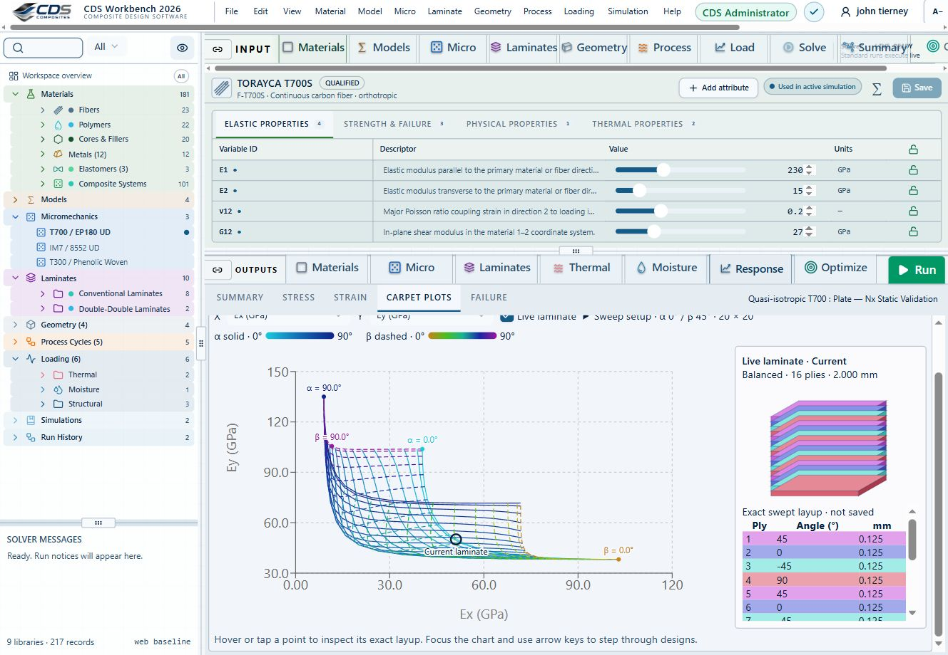
A linked carpet plot and laminate stack make the selected design visible alongside its properties.
Workbench capture · September 6, 2026 . Representative interface and demo data, not a new solver run or validation certificate. Control locations may differ in later releases.
Trace the selected input path
Ply property source
Include thermal analysis
Include moisture analysis
Include optional fatigue assessment
Stored ply properties bypass Micro. Mixed stacks keep both paths. Gray blocks are not selected. Geometry, process schedules and other model records are omitted here for clarity; a real run must include all required references.
Fatigue uses intact CLT endpoint stresses and measured S–N calibration. It is evaluated separately from Run and progressive failure. The dashed handoff is not active: optimization still uses current properties until a degradation law is supplied.
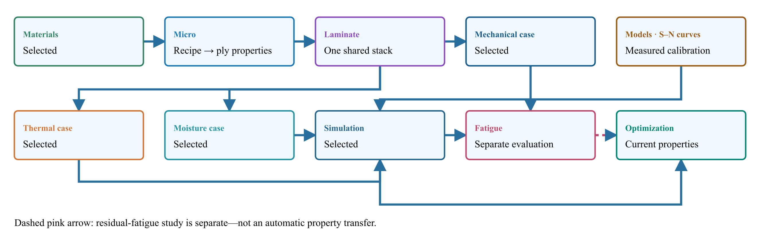
Materials → Micro → Laminate.
02.7 / How CDS solves it
From engineering question to evidence

Compare properties
Select one or more materials, laminas, laminates, simulations or optimization snapshots and review scrollable tables, bar charts, Ashby plots, line plots, property maps, and laminate stiffness matrices.

Explore field response
Move result cursors through time and thickness to update linked thermal plots, or select stress, strain, displacement, resultant, and factor-of-safety views for a structural case.

Export the evidence
Right-click supported tables to save CSV or XLSX data and presentation-oriented PPTX output where available, or write supported material cards for downstream finite-element analysis.
Workbench availability: released models, inputs and compatible study paths . The wider theory library includes reference formulations not available in every Workbench solve.
Released models, connections and theory
Complete model directory
∑ Micromechanics
Models browser → Micromechanics · source: Micro
Inputs Constituents, architecture, fractions and calibrated modifiers Results / handoff Reference ply properties for each linked laminate ply
One compatible homogenization model per Micro recipe. Use separate recipes for comparisons; they are not combined in a single ply.
Formulations and study choices
- Halpin–Tsai
- Rule of mixtures
- Modified rule of mixtures
- Chamis
- Mori–Tanaka
- Hashin–Rosen
- Self-consistent scheme
- Woven fabric bridging
- Cox shear-lag elastic
∑ Theory & assumptions
Guided exercise & two-layer workflow
∑ Cure, crystallization & material transport
Models → material-model folders · assigned through Materials
Inputs Calibrated kinetics, modulus or transport laws and material assignment Results / handoff Material laws consumed by compatible Micro or transport calculations
Independent model records can be linked together through material inputs. A saved model must be assigned to a material before it contributes to a simulation.
Formulations and study choices
- Kamal–Sourour autocatalytic
- Kamal–Sourour with diffusion control
- Nth-order Arrhenius
- CHILE (degree of cure)
- UV intensity-dependent cure
- Nakamura–Avrami
- Temperature-dependent tabular
- 1D Fickian diffusion
∑ Theory & assumptions
Guided exercise & two-layer workflow
· Cure kinetics
· Crystallization kinetics
∑ Thermal transport
Models browser → Thermal transport · source: CASES / Thermal
Inputs Laminate transport properties, initial state and the thermal case’s own surface cycle Results / handoff Temperature and supported polymer-state histories; mapped fields only when coupling is enabled
One transport formulation per thermal case. Select its laminate and configure its own initial conditions and surface cycle; pultrusion additionally requires a distance-based die schedule and pulling velocity.
Formulations and study choices
- 1D transient heat transfer
- 1D steady-state heat transfer
- 1D pultrusion thermal cure
∑ Theory & assumptions
Guided exercise & two-layer workflow
· Pultrusion exercise
· UV cure exercise
∑ Moisture transport
Models browser → Moisture transport · source: CASES / Moisture
Inputs Laminate diffusion properties, initial moisture and its own boundary schedule Results / handoff Moisture history and enabled swelling contribution
One formulation per moisture analysis. Thermal and moisture analyses can both be linked in Simulation; each needs its own boundary conditions.
Formulations and study choices
- 1D transient moisture diffusion
- 1D steady-state moisture diffusion
∑ Theory & assumptions
Guided exercise & two-layer workflow
∑ Plate · CLT & FSDT
Structural models → Laminate mechanics · CLT / FSDT
Inputs Laminate stiffness, finite plate dimensions, supported edges and study choice Results / handoff FSDT static bending or selected buckling / modal results; not progressive damage
Choose a formulation and study. Buckling and modal can be requested together; static bending requires FSDT. These are reference-elastic studies, separate from coupled process or progressive failure.
Formulations and study choices
- CLT
- FSDT
- Static bending
- Modal
- Buckling
- Buckling and modal
∑ Theory & assumptions
Guided exercise & two-layer workflow
∑ Cylinder
Structural models → Cylinder models
Inputs Laminate, cylinder dimensions and formulation-compatible pressure / axial loading Results / handoff Thin-wall membrane response or layerwise radial fields, with distinct assumptions
Choose one cylinder formulation per case record. Geometry and plies remain shared; thick-wall radial results exclude torsion and process strains.
Formulations and study choices
- Linear thin-wall membrane
- Layerwise thick-wall elasticity
∑ Theory & assumptions
Guided exercise & two-layer workflow
· Layerwise thick-wall theory
∑ Membrane, bending & beam buckling
Structural models → Laminate mechanics → Membrane, bending & beam
Inputs Laminate, compatible section and static or Euler load case Results / handoff Membrane / bending response or separate Euler buckling result
Geometry and the case determine the membrane or beam-test interpretation. Euler buckling requires a compatible beam section and a separate reference-elastic study; it is not a strength or local-buckling pass.
Formulations and study choices
- Linear static
- Linear static with failure indices
- Beam Euler buckling
∑ Theory & assumptions
Guided exercise & two-layer workflow
∑ Layerwise sections, joints & delamination
Structural models → Layerwise sections & joints
Inputs Section or lap geometry, laminate, loads and calibrated interface properties Results / handoff x–z fields; coupled ply damage and delamination only for the supported layerwise plate path
Coupled delamination is available only for the layerwise Plate section and needs calibrated interface and ply properties. Lap-shear uses its separate joint geometry and perfectly bonded elastic formulation.
Formulations and study choices
- Layerwise x-z plane strain
- Single-lap x-z plane strain
- Coupled delamination growth
∑ Theory & assumptions
Guided exercise & two-layer workflow
· Cohesive interface theory
∑ Sandwich bending
Structural models → Sandwich bending
Inputs Faces, core, dimensions and three-point-bend load Results / handoff Deflection and separate face, core and nominal bond-shear screening
Dedicated sandwich screening. Check core, faces and nominal bond shear separately; peel, mixed-mode debonding and crack growth are not assessed.
Formulations and study choices
- Sandwich three-point bend
∑ Theory & assumptions
Guided exercise & two-layer workflow
∑ Failure & envelope comparison
Structural models → Laminate mechanics → Failure criteria
Inputs Eligible CLT load case, strengths / strain limits and selected criterion Results / handoff First-ply envelopes or supported progressive ply-damage histories; criteria are not blended
One primary failure criterion per load. In Response → Failure, compare all eligible theories or a custom selection in the envelope controls. Each theory runs independently; criteria are not blended.
Formulations and study choices
- Maximum stress
- Maximum strain
- Tsai–Hill
- Tsai–Wu
- Hashin
∑ Theory & assumptions
Guided exercise & two-layer workflow
· Failure equations
· Implemented Workbench methods
∑ Fatigue S–N
Structural models → Laminate mechanics → Fatigue
Inputs Intact ply stresses, cyclic loads and measured S–N calibration Results / handoff Separate life assessment; no automatic laminate degradation
Select calibrated S–N curves for each material, direction and stress sign in Fatigue. Different sources can use different models. S–N life does not define residual stiffness or strength.
Formulations and study choices
- Kim–Zhang
- Sendeckyj
- Weibull S–N
- Kohout–Vechet
- Basquin
∑ Theory & assumptions
Starter load case · add calibrated fatigue
∑ D6641 · Compression coupon
Models → Structural models → ASTM · Virtual Test Lab
Inputs Linked laminate and explicit specimen, load or measured calibration inputs Results / handoff Uniform small-strain compression using linked laminate Ex and thickness. Measured compressive strength supplies a screening ratio; fixture, tabs, buckling and failure evolution are not simulated.
Uniform small-strain compression using linked laminate Ex and thickness. Measured compressive strength supplies a screening ratio; fixture, tabs, buckling and failure evolution are not simulated.
Formulations and study choices
- Virtual test · compression coupon
∑ Theory & assumptions
Guided exercise & two-layer workflow
∑ D5379 / D7078 · Shear coupon
Models → Structural models → ASTM · Virtual Test Lab
Inputs Linked laminate and explicit specimen, load or measured calibration inputs Results / handoff Uniform nominal shear between notches using linked laminate Gxy and thickness. Not a notch/fixture stress field or nonlinear shear solution. Gauge length is the effective shear deformation length, not crosshead travel.
Uniform nominal shear between notches using linked laminate Gxy and thickness. Not a notch/fixture stress field or nonlinear shear solution. Gauge length is the effective shear deformation length, not crosshead travel.
Formulations and study choices
- Virtual test · nominal shear coupon
∑ Theory & assumptions
Guided exercise & two-layer workflow
∑ D5528 · DCB opening
Models → Structural models → ASTM · Virtual Test Lab
Inputs Linked laminate and explicit specimen, load or measured calibration inputs Results / handoff Ideal Euler–Bernoulli DCB with equal homogeneous 0° arms, each half the linked laminate thickness. No root rotation, shear, large displacement or cohesive growth. Critical load is an initiation estimate from supplied GIc.
Ideal Euler–Bernoulli DCB with equal homogeneous 0° arms, each half the linked laminate thickness. No root rotation, shear, large displacement or cohesive growth. Critical load is an initiation estimate from supplied GIc.
Formulations and study choices
- Virtual test · DCB beam compliance
∑ Theory & assumptions
Guided exercise & two-layer workflow
∑ D7905 · ENF sliding
Models → Structural models → ASTM · Virtual Test Lab
Inputs Linked laminate and explicit specimen, load or measured calibration inputs Results / handoff Ideal equal-arm, homogeneous 0° ENF beam; support span is twice the half-span. Crack must be shorter than the half-span. No shear/root correction or unstable crack growth. GIIc is supplied, not fitted automatically.
Ideal equal-arm, homogeneous 0° ENF beam; support span is twice the half-span. Crack must be shorter than the half-span. No shear/root correction or unstable crack growth. GIIc is supplied, not fitted automatically.
Formulations and study choices
- Virtual test · ENF beam compliance
∑ Theory & assumptions
Guided exercise & two-layer workflow
∑ D6671 · Mixed-mode fracture envelope
Models → Structural models → ASTM · Virtual Test Lab
Inputs Linked laminate and explicit specimen, load or measured calibration inputs Results / handoff Benzeggagh–Kenane envelope from calibrated GIc, GIIc and exponent. Supplied GI/GII are energy-release rates from a separate test reduction or analysis. This does not resolve the MMB lever fixture or propagate a crack.
Benzeggagh–Kenane envelope from calibrated GIc, GIIc and exponent. Supplied GI/GII are energy-release rates from a separate test reduction or analysis. This does not resolve the MMB lever fixture or propagate a crack.
Formulations and study choices
- Virtual test · BK mixed-mode envelope
∑ Theory & assumptions
Guided exercise & two-layer workflow
∑ D5229 · Moisture uptake calibration
Models → Structural models → ASTM · Virtual Test Lab
Inputs Linked laminate and explicit specimen, load or measured calibration inputs Results / handoff Homogeneous slab, initially dry, both faces held at equilibrium moisture. Fits diffusivity from two early uptake measurements (both ≤50% saturation) using the square-root-time approximation. Edge ingress and temperature dependence are excluded. Does not overwrite material properties.
Homogeneous slab, initially dry, both faces held at equilibrium moisture. Fits diffusivity from two early uptake measurements (both ≤50% saturation) using the square-root-time approximation. Edge ingress and temperature dependence are excluded. Does not overwrite material properties.
Formulations and study choices
- Virtual test · Fickian uptake calibration
∑ Theory & assumptions
Guided exercise & two-layer workflow
∑ D5961 · Bearing / bypass screening
Models → Structural models → ASTM · Virtual Test Lab
Inputs Linked laminate and explicit specimen, load or measured calibration inputs Results / handoff Single-pin nominal bearing, net-section and shear-out checks with independent measured allowables. Bypass tension is added to net-section load only. No contact, bolt preload, load redistribution or validated bearing–bypass interaction envelope.
Single-pin nominal bearing, net-section and shear-out checks with independent measured allowables. Bypass tension is added to net-section load only. No contact, bolt preload, load redistribution or validated bearing–bypass interaction envelope.
Formulations and study choices
- Virtual test · bearing bypass screening
∑ Theory & assumptions
Guided exercise & two-layer workflow
∑ D6484 · Open-hole compression
Models → Structural models → ASTM · Virtual Test Lab
Inputs Linked laminate and explicit specimen, load or measured calibration inputs Results / handoff Nominal gross/net stress and demand relative to measured open-hole compressive strength for this geometry and layup. This is test-data screening, not an uncalibrated notch-strength prediction. No local buckling or kink-band simulation.
Nominal gross/net stress and demand relative to measured open-hole compressive strength for this geometry and layup. This is test-data screening, not an uncalibrated notch-strength prediction. No local buckling or kink-band simulation.
Formulations and study choices
- Virtual test · measured open-hole compression
∑ Theory & assumptions
Guided exercise & two-layer workflow
∑ D6742 · Filled-hole comparison
Models → Structural models → ASTM · Virtual Test Lab
Inputs Linked laminate and explicit specimen, load or measured calibration inputs Results / handoff Compares user-measured open- and filled-hole compressive strengths using gross-section stress. Use matched layup, hole, environment and fastener condition. Filling a hole does not automatically recover strength; no fastener contact/preload model is applied.
Compares user-measured open- and filled-hole compressive strengths using gross-section stress. Use matched layup, hole, environment and fastener condition. Filling a hole does not automatically recover strength; no fastener contact/preload model is applied.
Formulations and study choices
- Virtual test · measured filled-hole comparison
∑ Theory & assumptions
Guided exercise & two-layer workflow
∑ D7136 / D7137 · Impact & CAI assessment
Models → Structural models → ASTM · Virtual Test Lab
Inputs Linked laminate and explicit specimen, load or measured calibration inputs Results / handoff Incident energy from measured impact velocity; residual compressive strength from measured peak CAI force. Rebound energy estimates energy not returned to the striker, NOT damage energy. No impact/contact solver, damage-area prediction or energy-to-strength extrapolation.
Incident energy from measured impact velocity; residual compressive strength from measured peak CAI force. Rebound energy estimates energy not returned to the striker, NOT damage energy. No impact/contact solver, damage-area prediction or energy-to-strength extrapolation.
Formulations and study choices
- Virtual test · measured impact and CAI
∑ Theory & assumptions
Guided exercise & two-layer workflow
∑ Open-hole strength
Structural models → Laminate mechanics → Failure criteria → Open-hole strength
Inputs Specially orthotropic laminate, hole radius, unnotched strength and calibrated distances Results / handoff Point / average stress strength screening and radial stress profile
Infinite-width, specially orthotropic tension screening. Point and average stress distances must be calibrated independently for this laminate. Not compression, bearing or a joint allowable.
Formulations and study choices
- Whitney–Nuismer open-hole tension
∑ Theory & assumptions
Guided exercise & two-layer workflow
∑ Creep & stress relaxation
Structural models → Laminate mechanics → Creep & stress relaxation
Inputs Laminate Ex, Prony fractions / times and held stress or strain at calibration temperature Results / handoff Separate axial creep and relaxation curves with time-refinement safeguards
Linear uniaxial response at the calibration temperature. Reference Ex is the instantaneous modulus. Three Maxwell branches; creep is solved from stress equilibrium, not the reciprocal relaxation modulus. No thermal shifting or nonlinear creep.
Formulations and study choices
- Generalized Maxwell · axial Prony
∑ Theory & assumptions
Guided exercise & two-layer workflow
∑ Analytical bonded joint
Structural models → Layerwise sections & joints → Analytical bonded joint
Inputs Identical equivalent-elastic adherends, adhesive, overlap, width and tensile force Results / handoff Volkersen shear and Goland–Reissner shear / peel; no debond growth
Identical equivalent-elastic adherends, long free arms and a thin elastic adhesive. Compare shear-only Volkersen with eccentric single-lap shear and peel. Not a debonding, plasticity or strength calculation.
Formulations and study choices
- Volkersen & Goland–Reissner joint
∑ Theory & assumptions
Guided exercise & two-layer workflow
∑ LaRC04 failure initiation
Structural models → Laminate mechanics → Failure criteria → LaRC04
Inputs Laminate, membrane / bending resultants and calibrated effective ply strengths Results / handoff Linear-shear LaRC04 initiation indices at ply faces; no progressive degradation
NASA LaRC04 linear-shear specialization, evaluated at both faces of every ply under membrane and bending loads. Supplied ply strengths are effective/in-situ values; no automatic thin-ply enhancement. Initiation only, not degradation or nonlinear-shear instability.
Formulations and study choices
- LaRC04 · linear shear
∑ Theory & assumptions
Guided exercise & two-layer workflow
∑ Tool-release shape
Structural models → Tool-release shape
Inputs Laminate and prescribed temperatures, CTE and effective post-gel shrinkage Results / handoff Free-release CLT curvature and separate corner spring-in estimate; not an automatic process-history handoff
Free CLT release from prescribed ply-local shrinkage/thermal eigenstrains. Corner spring-in is a separate uniform-strain estimate. Stress-free temperature and effective post-gel shrinkage need calibration. No tool friction, cure kinetics or viscoelastic restraint history.
Formulations and study choices
- Free-release eigenstrain & spring-in
∑ Theory & assumptions
Guided exercise & two-layer workflow
∑ Fatigue residual properties
Structural models → Laminate mechanics → Fatigue → Residual properties
Inputs Modulus, independently fitted stiffness / strength retention laws, life and elapsed cycles Results / handoff Residual-property curves for the specified constant-amplitude calibration; saved laminate is unchanged
Prescribed power-law retention fitted to constant-amplitude tests at a fixed stress ratio, amplitude and temperature. Stiffness and strength have independent coefficients. S–N life alone cannot calibrate either. Does not modify the saved laminate.
Formulations and study choices
- Calibrated residual-property fatigue
∑ Theory & assumptions
Guided exercise & two-layer workflow
∑ Cylinder buckling
Structural models → Cylinder models → Cylinder buckling
Inputs Thin specially orthotropic shell, radius, length, axial compression and prescribed knockdown Results / handoff Ideal / knocked-down Donnell axial buckling and governing mode; no pressure or postbuckling
Simply supported, thin, specially orthotropic cylinder under uniform axial compression. Discrete Donnell modes; prescribed knockdown factor explores imperfection sensitivity, not a prediction from measured imperfection amplitude. No pressure, torsion, postbuckling or strength pass.
Formulations and study choices
- Donnell cylinder · axial buckling
∑ Theory & assumptions
Guided exercise & two-layer workflow
∑ Uncertainty & sensitivity
Structural models → Uncertainty & sensitivity
Inputs Laminate, bounded modulus / thickness / angle variations, seed and axial load Results / handoff ABD axial-strain percentiles and signed correlations; not certified reliability
Seeded independent uniform sampling of shared modulus, ply-thickness and angle offsets. Recomputes laminate ABD for each sample. Bounds are assumptions, not measured distributions. Percentiles and sensitivity are exploratory, not reliability certification.
Formulations and study choices
- Seeded laminate uncertainty
∑ Theory & assumptions
Guided exercise & two-layer workflow
∑ Wiener series and parallel
Models → Electromagnetics · RF → Wiener series and parallel
Inputs Explicit host/inclusion electrical properties and fractions Results / handoff Effective permittivity; manual handoff to an RF layer, not an automatic mechanical-property update
Positive lossless dielectric bounds; complex directional estimates.
Formulations and study choices
- EM · Wiener series and parallel
∑ Theory & assumptions
Guided exercise & two-layer workflow
∑ Looyenga / Landau–Lifshitz–Looyenga
Models → Electromagnetics · RF → Looyenga / Landau–Lifshitz–Looyenga
Inputs Explicit host/inclusion electrical properties and fractions Results / handoff Effective permittivity; manual handoff to an RF layer, not an automatic mechanical-property update
One cube-root mixing law, not two independent models.
Formulations and study choices
- EM · Looyenga / Landau–Lifshitz–Looyenga
∑ Theory & assumptions
Guided exercise & two-layer workflow
∑ Maxwell–Garnett
Models → Electromagnetics · RF → Maxwell–Garnett
Inputs Explicit host/inclusion electrical properties and fractions Results / handoff Effective permittivity; manual handoff to an RF layer, not an automatic mechanical-property update
Dilute subwavelength spherical inclusions in a host.
Formulations and study choices
- EM · Maxwell–Garnett
∑ Theory & assumptions
Guided exercise & two-layer workflow
∑ Normal-incidence laminate TMM
Models → Electromagnetics · RF → Normal-incidence laminate TMM
Inputs Explicit dielectric A/B layers, thicknesses, repetition, frequency and supported polarization Results / handoff Reflection, transmission, absorption and shielding spectra; no mechanical coupling
Coherent isotropic nonmagnetic layers between air half-spaces.
Formulations and study choices
- EM · Normal-incidence laminate TMM
∑ Theory & assumptions
Guided exercise & two-layer workflow
∑ Bruggeman symmetric EMT
Models → Electromagnetics · RF → Bruggeman symmetric EMT
Inputs Explicit host/inclusion electrical properties and fractions Results / handoff Effective permittivity; manual handoff to an RF layer, not an automatic mechanical-property update
Two positive-permittivity phases; no explicit contact network.
Formulations and study choices
- EM · Bruggeman symmetric EMT
∑ Theory & assumptions
Guided exercise & two-layer workflow
∑ EM Mori–Tanaka
Models → Electromagnetics · RF → EM Mori–Tanaka
Inputs Explicit host/inclusion electrical properties and fractions Results / handoff Effective permittivity; manual handoff to an RF layer, not an automatic mechanical-property update
Scalar principal-axis ellipsoidal field approximation.
Formulations and study choices
- EM · EM Mori–Tanaka
∑ Theory & assumptions
Guided exercise & two-layer workflow
∑ EM self-consistent
Models → Electromagnetics · RF → EM self-consistent
Inputs Explicit host/inclusion electrical properties and fractions Results / handoff Effective permittivity; manual handoff to an RF layer, not an automatic mechanical-property update
Scalar principal-axis self-consistency; spherical case equals Bruggeman.
Formulations and study choices
- EM · EM self-consistent
∑ Theory & assumptions
Guided exercise & two-layer workflow
∑ Differential effective medium
Models → Electromagnetics · RF → Differential effective medium
Inputs Explicit host/inclusion electrical properties and fractions Results / handoff Effective permittivity; manual handoff to an RF layer, not an automatic mechanical-property update
Incremental mixing with time-step refinement check.
Formulations and study choices
- EM · Differential effective medium
∑ Theory & assumptions
Guided exercise & two-layer workflow
∑ Coated sphere and interphase
Models → Electromagnetics · RF → Coated sphere and interphase
Inputs Explicit host/inclusion electrical properties and fractions Results / handoff Effective permittivity; manual handoff to an RF layer, not an automatic mechanical-property update
Concentric subwavelength coated spheres; no dynamic Mie scattering.
Formulations and study choices
- EM · Coated sphere and interphase
∑ Theory & assumptions
Guided exercise & two-layer workflow
∑ Generalized multiphase EMT
Models → Electromagnetics · RF → Generalized multiphase EMT
Inputs Explicit host/inclusion electrical properties and fractions Results / handoff Effective permittivity; manual handoff to an RF layer, not an automatic mechanical-property update
Spherical multiphase Bruggeman with convergence checks.
Formulations and study choices
- EM · Generalized multiphase EMT
∑ Theory & assumptions
Guided exercise & two-layer workflow
∑ Oblique polarized laminate TMM
Models → Electromagnetics · RF → Oblique polarized laminate TMM
Inputs Explicit dielectric A/B layers, thicknesses, repetition, frequency and supported polarization Results / handoff Reflection, transmission, absorption and shielding spectra; no mechanical coupling
TE or TM waves; scalar isotropic layers, no polarization conversion.
Formulations and study choices
- EM · Oblique polarized laminate TMM
∑ Theory & assumptions
Guided exercise & two-layer workflow
∑ 1D transmission line matrix
Models → Electromagnetics · RF → 1D transmission line matrix
Inputs Explicit dielectric A/B layers, thicknesses, repetition, frequency and supported polarization Results / handoff Reflected and transmitted pulse histories and spectra; mesh and energy checks
Normal-incidence lossless delay-line mesh with pulse decay, energy and mesh-refinement safeguards. Explicit Run required; not a 3D solver.
Formulations and study choices
- EM · 1D transmission line matrix
∑ Theory & assumptions
Guided exercise & two-layer workflow
∑ 1D Floquet–Bloch periodic layers
Models → Electromagnetics · RF → 1D Floquet–Bloch periodic layers
Inputs Explicit dielectric A/B layers, thicknesses, repetition, frequency and supported polarization Results / handoff Periodic-cell eigenvalues, folded Bloch phase and stop-band decay
Lossless isotropic A/B unit-cell eigenvalues, folded Bloch phase and stop-band attenuation at normal incidence. Not arbitrary-cell homogenization.
Formulations and study choices
- EM · 1D Floquet–Bloch periodic layers
∑ Theory & assumptions
Guided exercise & two-layer workflow
Outcomes and boundaries
- Results update from the active tree selection
- Charts and tables provide complementary views of the same solution
- Mechanical, thermal, moisture, and total response can be reviewed separately
Delivered capability
Methods available in CDS
Bar charts compare up to three properties; Ashby views compare any two
Linear and logarithmic scales are available for property comparison
Legend hover highlights its plotted records when practical
3D views provide fill, opacity, extrema and autoscale controls
Thermal cursors link time-history and through-thickness plots
Right-click supported tables to export CSV, XLSX or PPTX evidence
Next capability 02.1 Connected engineering data →

3 Connect engineering work through the CDS cloud
Online chapter
Extend the integrated model chain into secure collaboration, managed user access, versioned engineering records, shared examples, license delivery, and reusable cloud-supported workflows.
03.6 / Workflow focus
Connected engineering record

Connected user accounts
One verified CDS account connects licensing, approved downloads, forum participation, and shared engineering resources without requiring a ChatGPT login.

Versioned engineering records
Model inputs, assumptions, releases, and outputs can be organized as traceable records so a design decision can be revisited and reproduced.

Shared examples and guidance
Source-grounded examples, technical references, workflow guidance, and training remain available alongside the models they explain.

Account entitlement
The cloud account workflow authorizes project roles, module access, Recipe execution, and result retrieval through the same secured user record.

Collaboration and forum
Engineers can discuss methods, exchange model context, and connect questions to the relevant CDS workflow and theory pages.

Share an understandable study
Carry material sources, assumptions and results into reports and further analysis so another researcher can follow the engineering reasoning.
Use this workflow in Workbench: interactive Blocks, record selections and connection controls →
Next workflow page 03.1 Materials →

4 Evaluate the complete composite structure
Online chapter
Choose a compatible released plate, cylinder, beam, section, joint or analytical study. Shared laminate inputs do not make every model combination valid.

Select cases and inspect your model
Inspect the selected model in Live Sim
SIMULATE opens with Live Sim, an input-driven view of the selected cases. The four selectors remain available above the scene. Switch to Blocks to manage candidate records and trace their connections.
- Select Geometry, Laminate, a constituent or a case to inspect the inputs that are actually used. Clicking a used block heading also opens its Live Sim inspection.
- Select a ply in the stack or geometry view to inspect its source. Micro-derived and stored-property plies are identified separately. Woven sources show the fabric unit-cell preview when applicable.
- Select the Thermal or Moisture case to inspect its surface boundary schedule. Move the step slider to compare prescribed conditions. This is not a solved internal temperature or moisture field.
- Use Edit input to open the source record. The scene follows the changed inputs; rerun the simulation before trusting previous results.
Geometry, ply bands and arrows are input illustrations, not a finite-element mesh or solved deformation. Display-only thickness enlargement and any model-specific visualization assumptions are identified in the preview.
Choose the run in the SIMULATION block
SIMULATION is the control point for the run. Select a Thermal case, Moisture case, Mechanical case and EM case, or None in any slot. Each selected case shows its analysis model, laminate and applicable geometry.
- Keep candidate records in the surrounding blocks. Adding a candidate does not select it for execution.
- Select the required cases in SIMULATION and review their inputs before Run. At least one case is required.
- Use the same laminate for a supported combined run. Run standalone studies separately with the other selectors set to None.
- Run executes the selected combination. A connection or Used marker is not evidence of a successful solve.
Selecting several cases does not add unsupported physics coupling. EM screening studies do not automatically heat the thermal case.
Review every downstream geometry dependency
A geometry record can be shared by several cases and simulations. Editing its dimensions or type affects all linked consumers, including studies that are not currently open. Unrelated records are unchanged.
- After editing geometry, open Solver messages and expand Review affected cases and simulations. Select a linked name to inspect that record.
- Check the selected model, load basis, dimensions and boundary conditions. Loads are not automatically replaced when the geometry changes.
- Resolve incompatible geometry and model combinations before running. An I-section does not turn a plate theory into a beam theory.
- Rerun affected simulations before relying on previous results. Inputs changed warnings indicate that stored results no longer match their connected inputs.
Geometry affects only dimensions consumed by the selected model. One-dimensional transport retains its through-thickness assumptions; standalone studies may own their dimensions. Under fixed total edge loads, changing plate width changes force per unit width. Under prescribed resultants, it does not.
Complete block workflow guide
Trace the selected input path
Ply property source
Include thermal analysis
Include moisture analysis
Include optional fatigue assessment
Stored ply properties bypass Micro. Mixed stacks keep both paths. Gray blocks are not selected. Geometry, process schedules and other model records are omitted here for clarity; a real run must include all required references.
Fatigue uses intact CLT endpoint stresses and measured S–N calibration. It is evaluated separately from Run and progressive failure. The dashed handoff is not active: optimization still uses current properties until a degradation law is supplied.
Materials → Micro → Laminate.
03.5 / Workflow focus
Connected engineering record

Plate and beam response
Use the released CLT/FSDT finite-plate or membrane/beam path with compatible dimensions, loads and supports. Buckling, modal and static bending are distinct study choices.

Cylinder formulations
Thin-wall membrane and layerwise thick-wall elasticity have different load and process limits. Donnell axial buckling is a separate thin-shell study with an explicit knockdown factor.

Sections and joints
Layerwise sections, lap joints and sandwich bending have their own geometry and interfaces. The analytical Volkersen / Goland–Reissner study is a separate identical-adherend elastic approximation.

Failure and notches
The five existing criteria support eligible CLT first-ply / progressive calculations. LaRC04 linear-shear initiation and calibrated open-hole strength are separate studies, not additional progressive choices.

Fatigue
S–N models predict life from calibrated data. Residual stiffness / strength requires independently fitted retention laws in its separate study; neither automatically changes optimization properties.

Creep shape and uncertainty
Reference-state studies explore time response, prescribed-eigenstrain free release and bounded ABD sampling. Their scope, inputs and output handoffs are listed below.

Keep evidence connected
Run the selected Simulation after relevant edits. Review model assumptions, stale-result warnings, convergence and calibration before interpreting the result.
Workbench availability: released models, inputs and compatible study paths . The wider theory library includes reference formulations not available in every Workbench solve.
Use this workflow in Workbench: interactive Blocks, record selections and connection controls →

Design released model connections
Expand a family for inputs, outputs, supported formulations, theory and an exercise. All model families
∑ Plate · CLT & FSDT
Structural models → Laminate mechanics · CLT / FSDT
Inputs Laminate stiffness, finite plate dimensions, supported edges and study choice Results / handoff FSDT static bending or selected buckling / modal results; not progressive damage
Choose a formulation and study. Buckling and modal can be requested together; static bending requires FSDT. These are reference-elastic studies, separate from coupled process or progressive failure.
Formulations and study choices
- CLT
- FSDT
- Static bending
- Modal
- Buckling
- Buckling and modal
∑ Theory & assumptions
Guided exercise & two-layer workflow
∑ Cylinder
Structural models → Cylinder models
Inputs Laminate, cylinder dimensions and formulation-compatible pressure / axial loading Results / handoff Thin-wall membrane response or layerwise radial fields, with distinct assumptions
Choose one cylinder formulation per case record. Geometry and plies remain shared; thick-wall radial results exclude torsion and process strains.
Formulations and study choices
- Linear thin-wall membrane
- Layerwise thick-wall elasticity
∑ Theory & assumptions
Guided exercise & two-layer workflow
· Layerwise thick-wall theory
∑ Membrane, bending & beam buckling
Structural models → Laminate mechanics → Membrane, bending & beam
Inputs Laminate, compatible section and static or Euler load case Results / handoff Membrane / bending response or separate Euler buckling result
Geometry and the case determine the membrane or beam-test interpretation. Euler buckling requires a compatible beam section and a separate reference-elastic study; it is not a strength or local-buckling pass.
Formulations and study choices
- Linear static
- Linear static with failure indices
- Beam Euler buckling
∑ Theory & assumptions
Guided exercise & two-layer workflow
∑ Layerwise sections, joints & delamination
Structural models → Layerwise sections & joints
Inputs Section or lap geometry, laminate, loads and calibrated interface properties Results / handoff x–z fields; coupled ply damage and delamination only for the supported layerwise plate path
Coupled delamination is available only for the layerwise Plate section and needs calibrated interface and ply properties. Lap-shear uses its separate joint geometry and perfectly bonded elastic formulation.
Formulations and study choices
- Layerwise x-z plane strain
- Single-lap x-z plane strain
- Coupled delamination growth
∑ Theory & assumptions
Guided exercise & two-layer workflow
· Cohesive interface theory
∑ Sandwich bending
Structural models → Sandwich bending
Inputs Faces, core, dimensions and three-point-bend load Results / handoff Deflection and separate face, core and nominal bond-shear screening
Dedicated sandwich screening. Check core, faces and nominal bond shear separately; peel, mixed-mode debonding and crack growth are not assessed.
Formulations and study choices
- Sandwich three-point bend
∑ Theory & assumptions
Guided exercise & two-layer workflow
∑ Failure & envelope comparison
Structural models → Laminate mechanics → Failure criteria
Inputs Eligible CLT load case, strengths / strain limits and selected criterion Results / handoff First-ply envelopes or supported progressive ply-damage histories; criteria are not blended
One primary failure criterion per load. In Response → Failure, compare all eligible theories or a custom selection in the envelope controls. Each theory runs independently; criteria are not blended.
Formulations and study choices
- Maximum stress
- Maximum strain
- Tsai–Hill
- Tsai–Wu
- Hashin
∑ Theory & assumptions
Guided exercise & two-layer workflow
· Failure equations
· Implemented Workbench methods
∑ Fatigue S–N
Structural models → Laminate mechanics → Fatigue
Inputs Intact ply stresses, cyclic loads and measured S–N calibration Results / handoff Separate life assessment; no automatic laminate degradation
Select calibrated S–N curves for each material, direction and stress sign in Fatigue. Different sources can use different models. S–N life does not define residual stiffness or strength.
Formulations and study choices
- Kim–Zhang
- Sendeckyj
- Weibull S–N
- Kohout–Vechet
- Basquin
∑ Theory & assumptions
Starter load case · add calibrated fatigue
∑ D6641 · Compression coupon
Models → Structural models → ASTM · Virtual Test Lab
Inputs Linked laminate and explicit specimen, load or measured calibration inputs Results / handoff Uniform small-strain compression using linked laminate Ex and thickness. Measured compressive strength supplies a screening ratio; fixture, tabs, buckling and failure evolution are not simulated.
Uniform small-strain compression using linked laminate Ex and thickness. Measured compressive strength supplies a screening ratio; fixture, tabs, buckling and failure evolution are not simulated.
Formulations and study choices
- Virtual test · compression coupon
∑ Theory & assumptions
Guided exercise & two-layer workflow
∑ D5379 / D7078 · Shear coupon
Models → Structural models → ASTM · Virtual Test Lab
Inputs Linked laminate and explicit specimen, load or measured calibration inputs Results / handoff Uniform nominal shear between notches using linked laminate Gxy and thickness. Not a notch/fixture stress field or nonlinear shear solution. Gauge length is the effective shear deformation length, not crosshead travel.
Uniform nominal shear between notches using linked laminate Gxy and thickness. Not a notch/fixture stress field or nonlinear shear solution. Gauge length is the effective shear deformation length, not crosshead travel.
Formulations and study choices
- Virtual test · nominal shear coupon
∑ Theory & assumptions
Guided exercise & two-layer workflow
∑ D5528 · DCB opening
Models → Structural models → ASTM · Virtual Test Lab
Inputs Linked laminate and explicit specimen, load or measured calibration inputs Results / handoff Ideal Euler–Bernoulli DCB with equal homogeneous 0° arms, each half the linked laminate thickness. No root rotation, shear, large displacement or cohesive growth. Critical load is an initiation estimate from supplied GIc.
Ideal Euler–Bernoulli DCB with equal homogeneous 0° arms, each half the linked laminate thickness. No root rotation, shear, large displacement or cohesive growth. Critical load is an initiation estimate from supplied GIc.
Formulations and study choices
- Virtual test · DCB beam compliance
∑ Theory & assumptions
Guided exercise & two-layer workflow
∑ D7905 · ENF sliding
Models → Structural models → ASTM · Virtual Test Lab
Inputs Linked laminate and explicit specimen, load or measured calibration inputs Results / handoff Ideal equal-arm, homogeneous 0° ENF beam; support span is twice the half-span. Crack must be shorter than the half-span. No shear/root correction or unstable crack growth. GIIc is supplied, not fitted automatically.
Ideal equal-arm, homogeneous 0° ENF beam; support span is twice the half-span. Crack must be shorter than the half-span. No shear/root correction or unstable crack growth. GIIc is supplied, not fitted automatically.
Formulations and study choices
- Virtual test · ENF beam compliance
∑ Theory & assumptions
Guided exercise & two-layer workflow
∑ D6671 · Mixed-mode fracture envelope
Models → Structural models → ASTM · Virtual Test Lab
Inputs Linked laminate and explicit specimen, load or measured calibration inputs Results / handoff Benzeggagh–Kenane envelope from calibrated GIc, GIIc and exponent. Supplied GI/GII are energy-release rates from a separate test reduction or analysis. This does not resolve the MMB lever fixture or propagate a crack.
Benzeggagh–Kenane envelope from calibrated GIc, GIIc and exponent. Supplied GI/GII are energy-release rates from a separate test reduction or analysis. This does not resolve the MMB lever fixture or propagate a crack.
Formulations and study choices
- Virtual test · BK mixed-mode envelope
∑ Theory & assumptions
Guided exercise & two-layer workflow
∑ D5229 · Moisture uptake calibration
Models → Structural models → ASTM · Virtual Test Lab
Inputs Linked laminate and explicit specimen, load or measured calibration inputs Results / handoff Homogeneous slab, initially dry, both faces held at equilibrium moisture. Fits diffusivity from two early uptake measurements (both ≤50% saturation) using the square-root-time approximation. Edge ingress and temperature dependence are excluded. Does not overwrite material properties.
Homogeneous slab, initially dry, both faces held at equilibrium moisture. Fits diffusivity from two early uptake measurements (both ≤50% saturation) using the square-root-time approximation. Edge ingress and temperature dependence are excluded. Does not overwrite material properties.
Formulations and study choices
- Virtual test · Fickian uptake calibration
∑ Theory & assumptions
Guided exercise & two-layer workflow
∑ D5961 · Bearing / bypass screening
Models → Structural models → ASTM · Virtual Test Lab
Inputs Linked laminate and explicit specimen, load or measured calibration inputs Results / handoff Single-pin nominal bearing, net-section and shear-out checks with independent measured allowables. Bypass tension is added to net-section load only. No contact, bolt preload, load redistribution or validated bearing–bypass interaction envelope.
Single-pin nominal bearing, net-section and shear-out checks with independent measured allowables. Bypass tension is added to net-section load only. No contact, bolt preload, load redistribution or validated bearing–bypass interaction envelope.
Formulations and study choices
- Virtual test · bearing bypass screening
∑ Theory & assumptions
Guided exercise & two-layer workflow
∑ D6484 · Open-hole compression
Models → Structural models → ASTM · Virtual Test Lab
Inputs Linked laminate and explicit specimen, load or measured calibration inputs Results / handoff Nominal gross/net stress and demand relative to measured open-hole compressive strength for this geometry and layup. This is test-data screening, not an uncalibrated notch-strength prediction. No local buckling or kink-band simulation.
Nominal gross/net stress and demand relative to measured open-hole compressive strength for this geometry and layup. This is test-data screening, not an uncalibrated notch-strength prediction. No local buckling or kink-band simulation.
Formulations and study choices
- Virtual test · measured open-hole compression
∑ Theory & assumptions
Guided exercise & two-layer workflow
∑ D6742 · Filled-hole comparison
Models → Structural models → ASTM · Virtual Test Lab
Inputs Linked laminate and explicit specimen, load or measured calibration inputs Results / handoff Compares user-measured open- and filled-hole compressive strengths using gross-section stress. Use matched layup, hole, environment and fastener condition. Filling a hole does not automatically recover strength; no fastener contact/preload model is applied.
Compares user-measured open- and filled-hole compressive strengths using gross-section stress. Use matched layup, hole, environment and fastener condition. Filling a hole does not automatically recover strength; no fastener contact/preload model is applied.
Formulations and study choices
- Virtual test · measured filled-hole comparison
∑ Theory & assumptions
Guided exercise & two-layer workflow
∑ D7136 / D7137 · Impact & CAI assessment
Models → Structural models → ASTM · Virtual Test Lab
Inputs Linked laminate and explicit specimen, load or measured calibration inputs Results / handoff Incident energy from measured impact velocity; residual compressive strength from measured peak CAI force. Rebound energy estimates energy not returned to the striker, NOT damage energy. No impact/contact solver, damage-area prediction or energy-to-strength extrapolation.
Incident energy from measured impact velocity; residual compressive strength from measured peak CAI force. Rebound energy estimates energy not returned to the striker, NOT damage energy. No impact/contact solver, damage-area prediction or energy-to-strength extrapolation.
Formulations and study choices
- Virtual test · measured impact and CAI
∑ Theory & assumptions
Guided exercise & two-layer workflow
∑ Open-hole strength
Structural models → Laminate mechanics → Failure criteria → Open-hole strength
Inputs Specially orthotropic laminate, hole radius, unnotched strength and calibrated distances Results / handoff Point / average stress strength screening and radial stress profile
Infinite-width, specially orthotropic tension screening. Point and average stress distances must be calibrated independently for this laminate. Not compression, bearing or a joint allowable.
Formulations and study choices
- Whitney–Nuismer open-hole tension
∑ Theory & assumptions
Guided exercise & two-layer workflow
∑ Creep & stress relaxation
Structural models → Laminate mechanics → Creep & stress relaxation
Inputs Laminate Ex, Prony fractions / times and held stress or strain at calibration temperature Results / handoff Separate axial creep and relaxation curves with time-refinement safeguards
Linear uniaxial response at the calibration temperature. Reference Ex is the instantaneous modulus. Three Maxwell branches; creep is solved from stress equilibrium, not the reciprocal relaxation modulus. No thermal shifting or nonlinear creep.
Formulations and study choices
- Generalized Maxwell · axial Prony
∑ Theory & assumptions
Guided exercise & two-layer workflow
∑ Analytical bonded joint
Structural models → Layerwise sections & joints → Analytical bonded joint
Inputs Identical equivalent-elastic adherends, adhesive, overlap, width and tensile force Results / handoff Volkersen shear and Goland–Reissner shear / peel; no debond growth
Identical equivalent-elastic adherends, long free arms and a thin elastic adhesive. Compare shear-only Volkersen with eccentric single-lap shear and peel. Not a debonding, plasticity or strength calculation.
Formulations and study choices
- Volkersen & Goland–Reissner joint
∑ Theory & assumptions
Guided exercise & two-layer workflow
∑ LaRC04 failure initiation
Structural models → Laminate mechanics → Failure criteria → LaRC04
Inputs Laminate, membrane / bending resultants and calibrated effective ply strengths Results / handoff Linear-shear LaRC04 initiation indices at ply faces; no progressive degradation
NASA LaRC04 linear-shear specialization, evaluated at both faces of every ply under membrane and bending loads. Supplied ply strengths are effective/in-situ values; no automatic thin-ply enhancement. Initiation only, not degradation or nonlinear-shear instability.
Formulations and study choices
- LaRC04 · linear shear
∑ Theory & assumptions
Guided exercise & two-layer workflow
∑ Tool-release shape
Structural models → Tool-release shape
Inputs Laminate and prescribed temperatures, CTE and effective post-gel shrinkage Results / handoff Free-release CLT curvature and separate corner spring-in estimate; not an automatic process-history handoff
Free CLT release from prescribed ply-local shrinkage/thermal eigenstrains. Corner spring-in is a separate uniform-strain estimate. Stress-free temperature and effective post-gel shrinkage need calibration. No tool friction, cure kinetics or viscoelastic restraint history.
Formulations and study choices
- Free-release eigenstrain & spring-in
∑ Theory & assumptions
Guided exercise & two-layer workflow
∑ Fatigue residual properties
Structural models → Laminate mechanics → Fatigue → Residual properties
Inputs Modulus, independently fitted stiffness / strength retention laws, life and elapsed cycles Results / handoff Residual-property curves for the specified constant-amplitude calibration; saved laminate is unchanged
Prescribed power-law retention fitted to constant-amplitude tests at a fixed stress ratio, amplitude and temperature. Stiffness and strength have independent coefficients. S–N life alone cannot calibrate either. Does not modify the saved laminate.
Formulations and study choices
- Calibrated residual-property fatigue
∑ Theory & assumptions
Guided exercise & two-layer workflow
∑ Cylinder buckling
Structural models → Cylinder models → Cylinder buckling
Inputs Thin specially orthotropic shell, radius, length, axial compression and prescribed knockdown Results / handoff Ideal / knocked-down Donnell axial buckling and governing mode; no pressure or postbuckling
Simply supported, thin, specially orthotropic cylinder under uniform axial compression. Discrete Donnell modes; prescribed knockdown factor explores imperfection sensitivity, not a prediction from measured imperfection amplitude. No pressure, torsion, postbuckling or strength pass.
Formulations and study choices
- Donnell cylinder · axial buckling
∑ Theory & assumptions
Guided exercise & two-layer workflow
∑ Uncertainty & sensitivity
Structural models → Uncertainty & sensitivity
Inputs Laminate, bounded modulus / thickness / angle variations, seed and axial load Results / handoff ABD axial-strain percentiles and signed correlations; not certified reliability
Seeded independent uniform sampling of shared modulus, ply-thickness and angle offsets. Recomputes laminate ABD for each sample. Bounds are assumptions, not measured distributions. Percentiles and sensitivity are exploratory, not reliability certification.
Formulations and study choices
- Seeded laminate uncertainty
∑ Theory & assumptions
Guided exercise & two-layer workflow
∑ Normal-incidence laminate TMM
Models → Electromagnetics · RF → Normal-incidence laminate TMM
Inputs Explicit dielectric A/B layers, thicknesses, repetition, frequency and supported polarization Results / handoff Reflection, transmission, absorption and shielding spectra; no mechanical coupling
Coherent isotropic nonmagnetic layers between air half-spaces.
Formulations and study choices
- EM · Normal-incidence laminate TMM
∑ Theory & assumptions
Guided exercise & two-layer workflow
∑ Oblique polarized laminate TMM
Models → Electromagnetics · RF → Oblique polarized laminate TMM
Inputs Explicit dielectric A/B layers, thicknesses, repetition, frequency and supported polarization Results / handoff Reflection, transmission, absorption and shielding spectra; no mechanical coupling
TE or TM waves; scalar isotropic layers, no polarization conversion.
Formulations and study choices
- EM · Oblique polarized laminate TMM
∑ Theory & assumptions
Guided exercise & two-layer workflow
∑ 1D transmission line matrix
Models → Electromagnetics · RF → 1D transmission line matrix
Inputs Explicit dielectric A/B layers, thicknesses, repetition, frequency and supported polarization Results / handoff Reflected and transmitted pulse histories and spectra; mesh and energy checks
Normal-incidence lossless delay-line mesh with pulse decay, energy and mesh-refinement safeguards. Explicit Run required; not a 3D solver.
Formulations and study choices
- EM · 1D transmission line matrix
∑ Theory & assumptions
Guided exercise & two-layer workflow
∑ 1D Floquet–Bloch periodic layers
Models → Electromagnetics · RF → 1D Floquet–Bloch periodic layers
Inputs Explicit dielectric A/B layers, thicknesses, repetition, frequency and supported polarization Results / handoff Periodic-cell eigenvalues, folded Bloch phase and stop-band decay
Lossless isotropic A/B unit-cell eigenvalues, folded Bloch phase and stop-band attenuation at normal incidence. Not arbitrary-cell homogenization.
Formulations and study choices
- EM · 1D Floquet–Bloch periodic layers
∑ Theory & assumptions
Guided exercise & two-layer workflow
Next workflow page 03.6 Cloud →

5 Turn ply definitions into laminate decisions
Online chapter
Connect stored or Micro-derived ply properties to a stacking sequence, then choose a compatible structural or separate analytical study.
Inspect a ply stack
Angle pair ±θ: 45 °
Ply to resize
Selected ply thickness: 0.125 mm
8 plies · 1.000 mm total. Thickness is proportional in the section; line direction indicates angle, not a stress field.
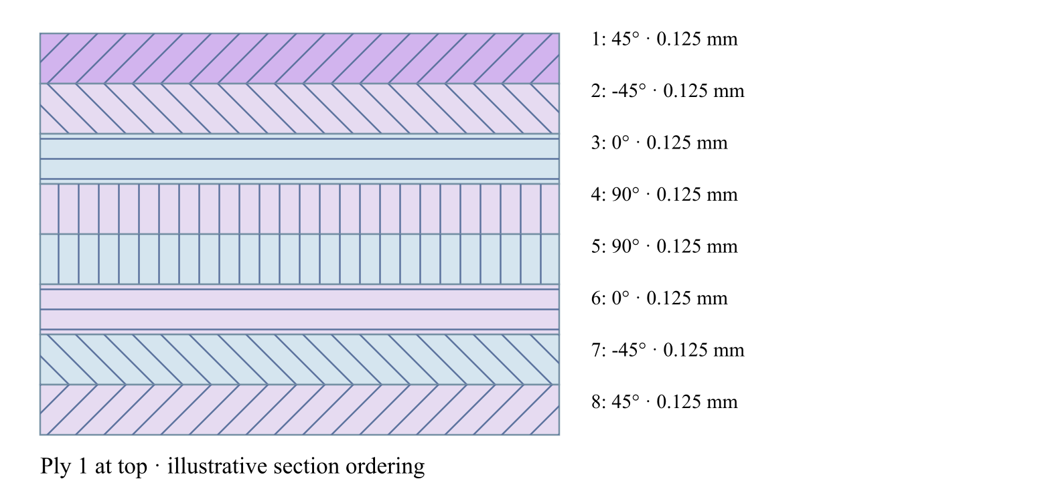
[θ / −θ / 0 / 90 / 90 / 0 / −θ / θ]
03.3 / Workflow focus
Connected engineering record

Ply stack
Set material references, angles and thicknesses. The stack defines laminate stiffness, mass and reference properties.

CLT and FSDT
ABD properties support laminate response. Finite-plate studies select CLT or FSDT within their supported boundary and study limits; static plate bending requires FSDT.

Failure and interfaces
Eligible CLT cases use the released failure criteria. Coupled delamination belongs to the supported layerwise section path with calibrated interfaces, not every plate solver.

Separate analytical studies
Open-hole strength, linear-shear LaRC04 initiation, axial creep and uncertainty use the linked laminate reference state. They do not automatically inherit process or progressive-damage histories.

Design exploration
Carpet maps and bounded optimization compare candidates. Apply a candidate and rerun the appropriate analysis; a saved result does not update itself.
Workbench availability: released models, inputs and compatible study paths . The wider theory library includes reference formulations not available in every Workbench solve.
Use this workflow in Workbench: interactive Blocks, record selections and connection controls →

Laminates released model connections
Expand a family for inputs, outputs, supported formulations, theory and an exercise. All model families
∑ Plate · CLT & FSDT
Structural models → Laminate mechanics · CLT / FSDT
Inputs Laminate stiffness, finite plate dimensions, supported edges and study choice Results / handoff FSDT static bending or selected buckling / modal results; not progressive damage
Choose a formulation and study. Buckling and modal can be requested together; static bending requires FSDT. These are reference-elastic studies, separate from coupled process or progressive failure.
Formulations and study choices
- CLT
- FSDT
- Static bending
- Modal
- Buckling
- Buckling and modal
∑ Theory & assumptions
Guided exercise & two-layer workflow
∑ Membrane, bending & beam buckling
Structural models → Laminate mechanics → Membrane, bending & beam
Inputs Laminate, compatible section and static or Euler load case Results / handoff Membrane / bending response or separate Euler buckling result
Geometry and the case determine the membrane or beam-test interpretation. Euler buckling requires a compatible beam section and a separate reference-elastic study; it is not a strength or local-buckling pass.
Formulations and study choices
- Linear static
- Linear static with failure indices
- Beam Euler buckling
∑ Theory & assumptions
Guided exercise & two-layer workflow
∑ Failure & envelope comparison
Structural models → Laminate mechanics → Failure criteria
Inputs Eligible CLT load case, strengths / strain limits and selected criterion Results / handoff First-ply envelopes or supported progressive ply-damage histories; criteria are not blended
One primary failure criterion per load. In Response → Failure, compare all eligible theories or a custom selection in the envelope controls. Each theory runs independently; criteria are not blended.
Formulations and study choices
- Maximum stress
- Maximum strain
- Tsai–Hill
- Tsai–Wu
- Hashin
∑ Theory & assumptions
Guided exercise & two-layer workflow
· Failure equations
· Implemented Workbench methods
∑ D6641 · Compression coupon
Models → Structural models → ASTM · Virtual Test Lab
Inputs Linked laminate and explicit specimen, load or measured calibration inputs Results / handoff Uniform small-strain compression using linked laminate Ex and thickness. Measured compressive strength supplies a screening ratio; fixture, tabs, buckling and failure evolution are not simulated.
Uniform small-strain compression using linked laminate Ex and thickness. Measured compressive strength supplies a screening ratio; fixture, tabs, buckling and failure evolution are not simulated.
Formulations and study choices
- Virtual test · compression coupon
∑ Theory & assumptions
Guided exercise & two-layer workflow
∑ D5379 / D7078 · Shear coupon
Models → Structural models → ASTM · Virtual Test Lab
Inputs Linked laminate and explicit specimen, load or measured calibration inputs Results / handoff Uniform nominal shear between notches using linked laminate Gxy and thickness. Not a notch/fixture stress field or nonlinear shear solution. Gauge length is the effective shear deformation length, not crosshead travel.
Uniform nominal shear between notches using linked laminate Gxy and thickness. Not a notch/fixture stress field or nonlinear shear solution. Gauge length is the effective shear deformation length, not crosshead travel.
Formulations and study choices
- Virtual test · nominal shear coupon
∑ Theory & assumptions
Guided exercise & two-layer workflow
∑ D5528 · DCB opening
Models → Structural models → ASTM · Virtual Test Lab
Inputs Linked laminate and explicit specimen, load or measured calibration inputs Results / handoff Ideal Euler–Bernoulli DCB with equal homogeneous 0° arms, each half the linked laminate thickness. No root rotation, shear, large displacement or cohesive growth. Critical load is an initiation estimate from supplied GIc.
Ideal Euler–Bernoulli DCB with equal homogeneous 0° arms, each half the linked laminate thickness. No root rotation, shear, large displacement or cohesive growth. Critical load is an initiation estimate from supplied GIc.
Formulations and study choices
- Virtual test · DCB beam compliance
∑ Theory & assumptions
Guided exercise & two-layer workflow
∑ D7905 · ENF sliding
Models → Structural models → ASTM · Virtual Test Lab
Inputs Linked laminate and explicit specimen, load or measured calibration inputs Results / handoff Ideal equal-arm, homogeneous 0° ENF beam; support span is twice the half-span. Crack must be shorter than the half-span. No shear/root correction or unstable crack growth. GIIc is supplied, not fitted automatically.
Ideal equal-arm, homogeneous 0° ENF beam; support span is twice the half-span. Crack must be shorter than the half-span. No shear/root correction or unstable crack growth. GIIc is supplied, not fitted automatically.
Formulations and study choices
- Virtual test · ENF beam compliance
∑ Theory & assumptions
Guided exercise & two-layer workflow
∑ D6671 · Mixed-mode fracture envelope
Models → Structural models → ASTM · Virtual Test Lab
Inputs Linked laminate and explicit specimen, load or measured calibration inputs Results / handoff Benzeggagh–Kenane envelope from calibrated GIc, GIIc and exponent. Supplied GI/GII are energy-release rates from a separate test reduction or analysis. This does not resolve the MMB lever fixture or propagate a crack.
Benzeggagh–Kenane envelope from calibrated GIc, GIIc and exponent. Supplied GI/GII are energy-release rates from a separate test reduction or analysis. This does not resolve the MMB lever fixture or propagate a crack.
Formulations and study choices
- Virtual test · BK mixed-mode envelope
∑ Theory & assumptions
Guided exercise & two-layer workflow
∑ D5961 · Bearing / bypass screening
Models → Structural models → ASTM · Virtual Test Lab
Inputs Linked laminate and explicit specimen, load or measured calibration inputs Results / handoff Single-pin nominal bearing, net-section and shear-out checks with independent measured allowables. Bypass tension is added to net-section load only. No contact, bolt preload, load redistribution or validated bearing–bypass interaction envelope.
Single-pin nominal bearing, net-section and shear-out checks with independent measured allowables. Bypass tension is added to net-section load only. No contact, bolt preload, load redistribution or validated bearing–bypass interaction envelope.
Formulations and study choices
- Virtual test · bearing bypass screening
∑ Theory & assumptions
Guided exercise & two-layer workflow
∑ D6484 · Open-hole compression
Models → Structural models → ASTM · Virtual Test Lab
Inputs Linked laminate and explicit specimen, load or measured calibration inputs Results / handoff Nominal gross/net stress and demand relative to measured open-hole compressive strength for this geometry and layup. This is test-data screening, not an uncalibrated notch-strength prediction. No local buckling or kink-band simulation.
Nominal gross/net stress and demand relative to measured open-hole compressive strength for this geometry and layup. This is test-data screening, not an uncalibrated notch-strength prediction. No local buckling or kink-band simulation.
Formulations and study choices
- Virtual test · measured open-hole compression
∑ Theory & assumptions
Guided exercise & two-layer workflow
∑ D6742 · Filled-hole comparison
Models → Structural models → ASTM · Virtual Test Lab
Inputs Linked laminate and explicit specimen, load or measured calibration inputs Results / handoff Compares user-measured open- and filled-hole compressive strengths using gross-section stress. Use matched layup, hole, environment and fastener condition. Filling a hole does not automatically recover strength; no fastener contact/preload model is applied.
Compares user-measured open- and filled-hole compressive strengths using gross-section stress. Use matched layup, hole, environment and fastener condition. Filling a hole does not automatically recover strength; no fastener contact/preload model is applied.
Formulations and study choices
- Virtual test · measured filled-hole comparison
∑ Theory & assumptions
Guided exercise & two-layer workflow
∑ D7136 / D7137 · Impact & CAI assessment
Models → Structural models → ASTM · Virtual Test Lab
Inputs Linked laminate and explicit specimen, load or measured calibration inputs Results / handoff Incident energy from measured impact velocity; residual compressive strength from measured peak CAI force. Rebound energy estimates energy not returned to the striker, NOT damage energy. No impact/contact solver, damage-area prediction or energy-to-strength extrapolation.
Incident energy from measured impact velocity; residual compressive strength from measured peak CAI force. Rebound energy estimates energy not returned to the striker, NOT damage energy. No impact/contact solver, damage-area prediction or energy-to-strength extrapolation.
Formulations and study choices
- Virtual test · measured impact and CAI
∑ Theory & assumptions
Guided exercise & two-layer workflow
∑ Open-hole strength
Structural models → Laminate mechanics → Failure criteria → Open-hole strength
Inputs Specially orthotropic laminate, hole radius, unnotched strength and calibrated distances Results / handoff Point / average stress strength screening and radial stress profile
Infinite-width, specially orthotropic tension screening. Point and average stress distances must be calibrated independently for this laminate. Not compression, bearing or a joint allowable.
Formulations and study choices
- Whitney–Nuismer open-hole tension
∑ Theory & assumptions
Guided exercise & two-layer workflow
∑ Creep & stress relaxation
Structural models → Laminate mechanics → Creep & stress relaxation
Inputs Laminate Ex, Prony fractions / times and held stress or strain at calibration temperature Results / handoff Separate axial creep and relaxation curves with time-refinement safeguards
Linear uniaxial response at the calibration temperature. Reference Ex is the instantaneous modulus. Three Maxwell branches; creep is solved from stress equilibrium, not the reciprocal relaxation modulus. No thermal shifting or nonlinear creep.
Formulations and study choices
- Generalized Maxwell · axial Prony
∑ Theory & assumptions
Guided exercise & two-layer workflow
∑ LaRC04 failure initiation
Structural models → Laminate mechanics → Failure criteria → LaRC04
Inputs Laminate, membrane / bending resultants and calibrated effective ply strengths Results / handoff Linear-shear LaRC04 initiation indices at ply faces; no progressive degradation
NASA LaRC04 linear-shear specialization, evaluated at both faces of every ply under membrane and bending loads. Supplied ply strengths are effective/in-situ values; no automatic thin-ply enhancement. Initiation only, not degradation or nonlinear-shear instability.
Formulations and study choices
- LaRC04 · linear shear
∑ Theory & assumptions
Guided exercise & two-layer workflow
∑ Uncertainty & sensitivity
Structural models → Uncertainty & sensitivity
Inputs Laminate, bounded modulus / thickness / angle variations, seed and axial load Results / handoff ABD axial-strain percentiles and signed correlations; not certified reliability
Seeded independent uniform sampling of shared modulus, ply-thickness and angle offsets. Recomputes laminate ABD for each sample. Bounds are assumptions, not measured distributions. Percentiles and sensitivity are exploratory, not reliability certification.
Formulations and study choices
- Seeded laminate uncertainty
∑ Theory & assumptions
Guided exercise & two-layer workflow
∑ Normal-incidence laminate TMM
Models → Electromagnetics · RF → Normal-incidence laminate TMM
Inputs Explicit dielectric A/B layers, thicknesses, repetition, frequency and supported polarization Results / handoff Reflection, transmission, absorption and shielding spectra; no mechanical coupling
Coherent isotropic nonmagnetic layers between air half-spaces.
Formulations and study choices
- EM · Normal-incidence laminate TMM
∑ Theory & assumptions
Guided exercise & two-layer workflow
∑ Oblique polarized laminate TMM
Models → Electromagnetics · RF → Oblique polarized laminate TMM
Inputs Explicit dielectric A/B layers, thicknesses, repetition, frequency and supported polarization Results / handoff Reflection, transmission, absorption and shielding spectra; no mechanical coupling
TE or TM waves; scalar isotropic layers, no polarization conversion.
Formulations and study choices
- EM · Oblique polarized laminate TMM
∑ Theory & assumptions
Guided exercise & two-layer workflow
∑ 1D transmission line matrix
Models → Electromagnetics · RF → 1D transmission line matrix
Inputs Explicit dielectric A/B layers, thicknesses, repetition, frequency and supported polarization Results / handoff Reflected and transmitted pulse histories and spectra; mesh and energy checks
Normal-incidence lossless delay-line mesh with pulse decay, energy and mesh-refinement safeguards. Explicit Run required; not a 3D solver.
Formulations and study choices
- EM · 1D transmission line matrix
∑ Theory & assumptions
Guided exercise & two-layer workflow
∑ 1D Floquet–Bloch periodic layers
Models → Electromagnetics · RF → 1D Floquet–Bloch periodic layers
Inputs Explicit dielectric A/B layers, thicknesses, repetition, frequency and supported polarization Results / handoff Periodic-cell eigenvalues, folded Bloch phase and stop-band decay
Lossless isotropic A/B unit-cell eigenvalues, folded Bloch phase and stop-band attenuation at normal incidence. Not arbitrary-cell homogenization.
Formulations and study choices
- EM · 1D Floquet–Bloch periodic layers
∑ Theory & assumptions
Guided exercise & two-layer workflow
Next workflow page 03.4 Processing →

6 Build a trusted materials foundation
Online chapter
Organize source-aware constituents, vendor records, prepregs, adhesives, cores, sandwich systems, diffusion data, cure kinetics, crystallization kinetics, reaction heat, and process shrinkage into reusable engineering records.
Trace the selected input path
Ply property source
Include thermal analysis
Include moisture analysis
Include optional fatigue assessment
Stored ply properties bypass Micro. Mixed stacks keep both paths. Gray blocks are not selected. Geometry, process schedules and other model records are omitted here for clarity; a real run must include all required references.
Fatigue uses intact CLT endpoint stresses and measured S–N calibration. It is evaluated separately from Run and progressive failure. The dashed handoff is not active: optimization still uses current properties until a degradation law is supplied.
Materials → Micro → Laminate.
03.1 / Workflow focus
Connected engineering record

Source-aware constituents
Keep elastic, strength, density and transport data with their units, sources and calibration basis.

Material models
Assign calibrated cure, crystallization, modulus or transport models through the material record. A model sitting in the tree does not contribute until it is linked.

Measured or predicted plies
A laminate ply can use a stored material or linked Micro recipe. Check the resolved properties before selecting the structural study.

Data handoff
Materials feed Micro and the linked laminate. Compatible transport studies evaluate the selected material laws; not every structural study includes processing.
Workbench availability: released models, inputs and compatible study paths . The wider theory library includes reference formulations not available in every Workbench solve.
Use this workflow in Workbench: interactive Blocks, record selections and connection controls →

Materials released model connections
Expand a family for inputs, outputs, supported formulations, theory and an exercise. All model families
∑ Cure, crystallization & material transport
Models → material-model folders · assigned through Materials
Inputs Calibrated kinetics, modulus or transport laws and material assignment Results / handoff Material laws consumed by compatible Micro or transport calculations
Independent model records can be linked together through material inputs. A saved model must be assigned to a material before it contributes to a simulation.
Formulations and study choices
- Kamal–Sourour autocatalytic
- Kamal–Sourour with diffusion control
- Nth-order Arrhenius
- CHILE (degree of cure)
- UV intensity-dependent cure
- Nakamura–Avrami
- Temperature-dependent tabular
- 1D Fickian diffusion
∑ Theory & assumptions
Guided exercise & two-layer workflow
· Cure kinetics
· Crystallization kinetics
Next workflow page 03.2 Micromechanics →

7 Translate constituents into effective material behavior
Online chapter
Choose a released architecture-compatible homogenization model, inspect its reference ply properties, and carry those properties into the laminate.

One cell A whole fabric
Explore plain, twill and satin yarn surfaces in Micro, Live Stack, CREATE and DISCOVER. Switch between one repeat and 2 × 2 or 3 × 3 cells, then rotate and zoom. CREATE carries the selected weave and woven bridging model into SIMULATE, subject to your license.
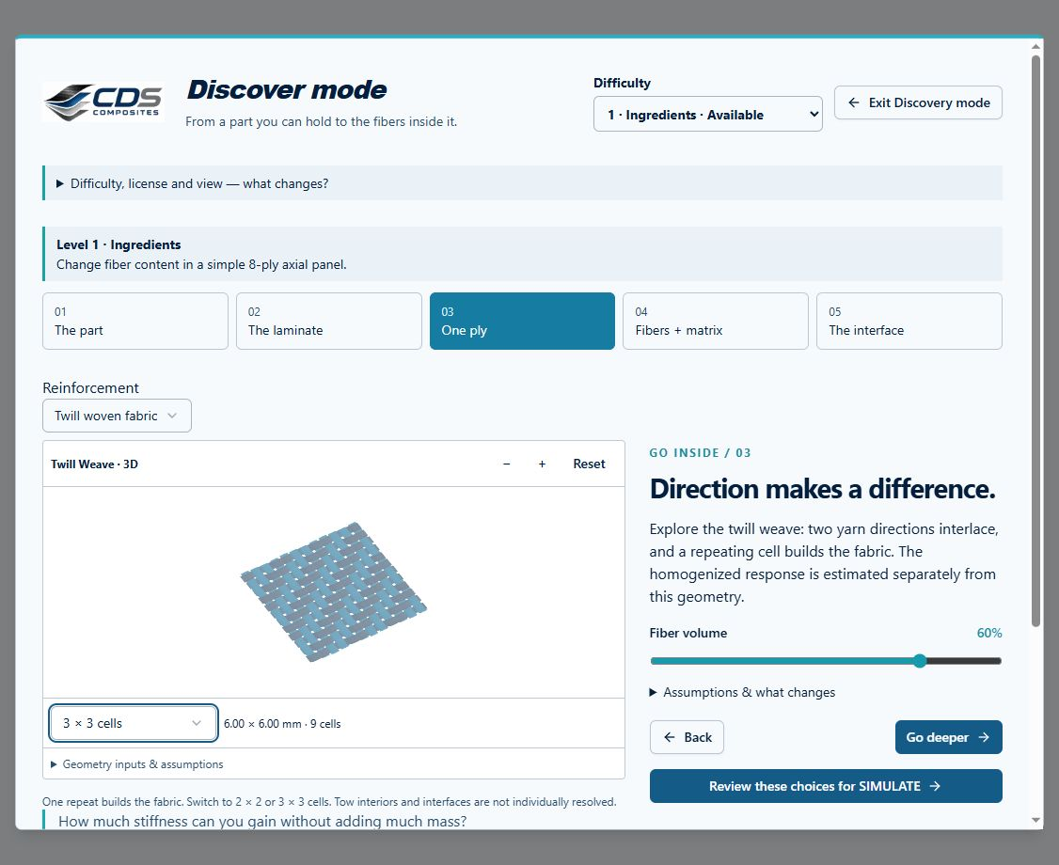
DISCOVER: repeat a twill unit cell into a fabric patch.
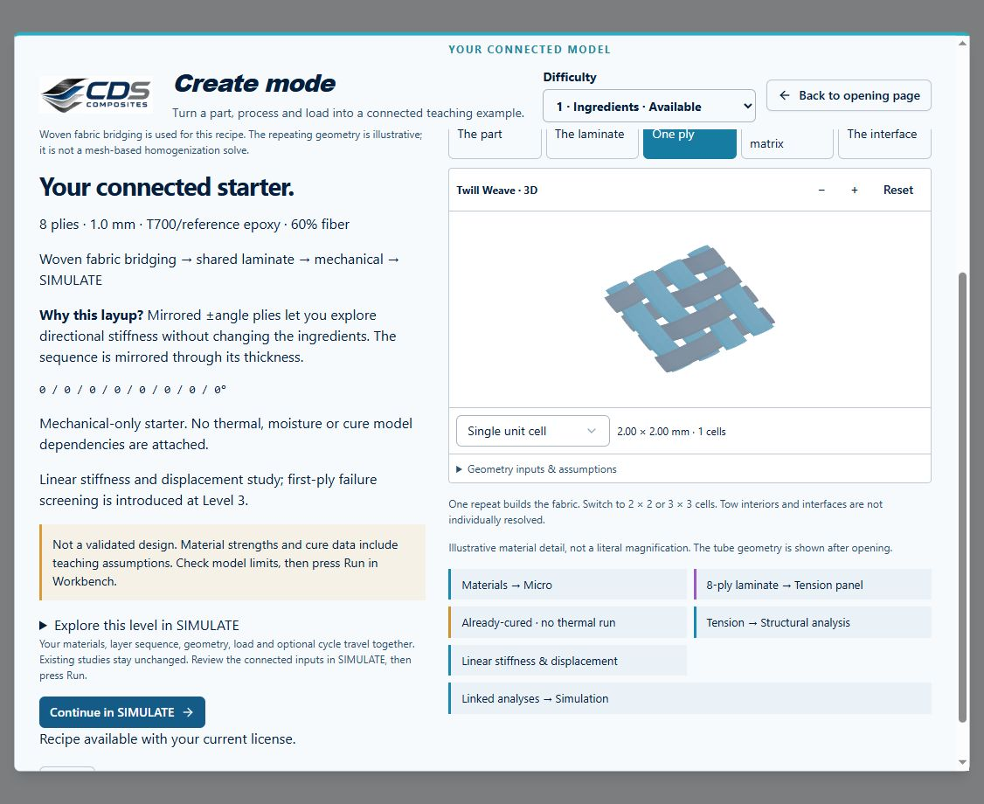
CREATE: carry the weave into a connected laminate recipe.
Captured from the Workbench components in a local preview, September 17, 2026. Missing yarn dimensions are inferred and listed under Geometry inputs & assumptions. These are periodic surface illustrations—not measured textile CAD, solid exports or a mesh-based solver. Effective properties are calculated separately by the selected micromechanics model.
Explore fiber volume
Fiber volume: 60 %
Void volume: 2 %
Fiber modulus
230 GPa
Matrix modulus
3.5 GPa
Matrix volume
38 %
Axial mixture estimate
139.33 GPa
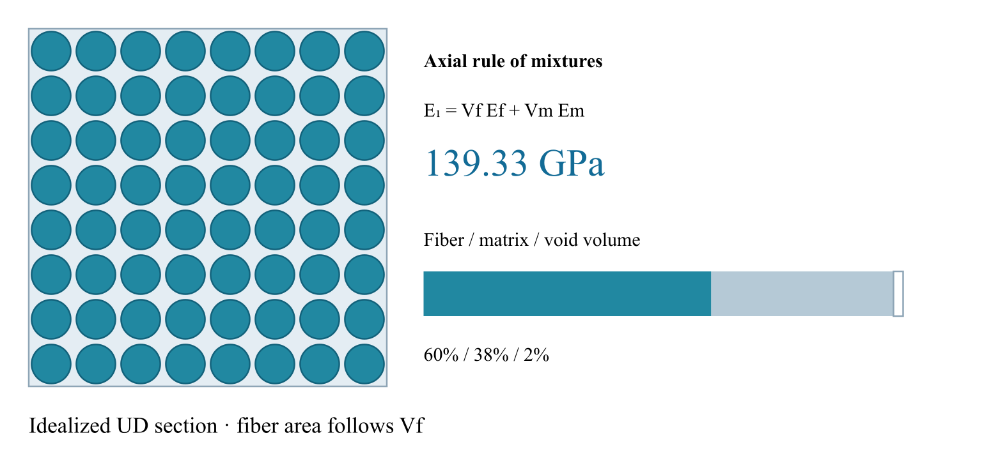
Zero-stiffness void phase; no empirical void knockdown or transverse prediction.
03.2 / Workflow focus
Connected engineering record

Compatible formulations
The Models browser lists rule-of-mixtures variants, Halpin–Tsai, Chamis, Mori–Tanaka, Hashin–Rosen, self-consistent, woven bridging and Cox elastic short-fiber choices. Architecture determines which choices are available.

Short-fiber scope
Cox shear-lag elastic studies use prescribed geometry and orientation. The event-driven Henry–Pimenta RVE and its stochastic discontinuous-fiber failure route are not enabled in the hosted release.

Ply-property handoff
The selected Micro recipe supplies reference properties to its linked plies. Shared material or Micro edits can change multiple laminate calculations.

Explore and compare
Use an exercise or supported property sweep to compare model assumptions, constituent limits and sensitivity. Predicted strengths and teaching defaults are not qualified allowables.
Workbench availability: released models, inputs and compatible study paths . The wider theory library includes reference formulations not available in every Workbench solve.
Use this workflow in Workbench: interactive Blocks, record selections and connection controls →

Micromechanics released model connections
Expand a family for inputs, outputs, supported formulations, theory and an exercise. All model families
∑ Micromechanics
Models browser → Micromechanics · source: Micro
Inputs Constituents, architecture, fractions and calibrated modifiers Results / handoff Reference ply properties for each linked laminate ply
One compatible homogenization model per Micro recipe. Use separate recipes for comparisons; they are not combined in a single ply.
Formulations and study choices
- Halpin–Tsai
- Rule of mixtures
- Modified rule of mixtures
- Chamis
- Mori–Tanaka
- Hashin–Rosen
- Self-consistent scheme
- Woven fabric bridging
- Cox shear-lag elastic
∑ Theory & assumptions
Guided exercise & two-layer workflow
∑ Wiener series and parallel
Models → Electromagnetics · RF → Wiener series and parallel
Inputs Explicit host/inclusion electrical properties and fractions Results / handoff Effective permittivity; manual handoff to an RF layer, not an automatic mechanical-property update
Positive lossless dielectric bounds; complex directional estimates.
Formulations and study choices
- EM · Wiener series and parallel
∑ Theory & assumptions
Guided exercise & two-layer workflow
∑ Looyenga / Landau–Lifshitz–Looyenga
Models → Electromagnetics · RF → Looyenga / Landau–Lifshitz–Looyenga
Inputs Explicit host/inclusion electrical properties and fractions Results / handoff Effective permittivity; manual handoff to an RF layer, not an automatic mechanical-property update
One cube-root mixing law, not two independent models.
Formulations and study choices
- EM · Looyenga / Landau–Lifshitz–Looyenga
∑ Theory & assumptions
Guided exercise & two-layer workflow
∑ Maxwell–Garnett
Models → Electromagnetics · RF → Maxwell–Garnett
Inputs Explicit host/inclusion electrical properties and fractions Results / handoff Effective permittivity; manual handoff to an RF layer, not an automatic mechanical-property update
Dilute subwavelength spherical inclusions in a host.
Formulations and study choices
- EM · Maxwell–Garnett
∑ Theory & assumptions
Guided exercise & two-layer workflow
∑ Bruggeman symmetric EMT
Models → Electromagnetics · RF → Bruggeman symmetric EMT
Inputs Explicit host/inclusion electrical properties and fractions Results / handoff Effective permittivity; manual handoff to an RF layer, not an automatic mechanical-property update
Two positive-permittivity phases; no explicit contact network.
Formulations and study choices
- EM · Bruggeman symmetric EMT
∑ Theory & assumptions
Guided exercise & two-layer workflow
∑ EM Mori–Tanaka
Models → Electromagnetics · RF → EM Mori–Tanaka
Inputs Explicit host/inclusion electrical properties and fractions Results / handoff Effective permittivity; manual handoff to an RF layer, not an automatic mechanical-property update
Scalar principal-axis ellipsoidal field approximation.
Formulations and study choices
- EM · EM Mori–Tanaka
∑ Theory & assumptions
Guided exercise & two-layer workflow
∑ EM self-consistent
Models → Electromagnetics · RF → EM self-consistent
Inputs Explicit host/inclusion electrical properties and fractions Results / handoff Effective permittivity; manual handoff to an RF layer, not an automatic mechanical-property update
Scalar principal-axis self-consistency; spherical case equals Bruggeman.
Formulations and study choices
- EM · EM self-consistent
∑ Theory & assumptions
Guided exercise & two-layer workflow
∑ Differential effective medium
Models → Electromagnetics · RF → Differential effective medium
Inputs Explicit host/inclusion electrical properties and fractions Results / handoff Effective permittivity; manual handoff to an RF layer, not an automatic mechanical-property update
Incremental mixing with time-step refinement check.
Formulations and study choices
- EM · Differential effective medium
∑ Theory & assumptions
Guided exercise & two-layer workflow
∑ Coated sphere and interphase
Models → Electromagnetics · RF → Coated sphere and interphase
Inputs Explicit host/inclusion electrical properties and fractions Results / handoff Effective permittivity; manual handoff to an RF layer, not an automatic mechanical-property update
Concentric subwavelength coated spheres; no dynamic Mie scattering.
Formulations and study choices
- EM · Coated sphere and interphase
∑ Theory & assumptions
Guided exercise & two-layer workflow
∑ Generalized multiphase EMT
Models → Electromagnetics · RF → Generalized multiphase EMT
Inputs Explicit host/inclusion electrical properties and fractions Results / handoff Effective permittivity; manual handoff to an RF layer, not an automatic mechanical-property update
Spherical multiphase Bruggeman with convergence checks.
Formulations and study choices
- EM · Generalized multiphase EMT
∑ Theory & assumptions
Guided exercise & two-layer workflow
Next workflow page 03.3 Laminates →

8 Models you can use Connections you can follow
Online chapter
The released Workbench model set, grouped by engineering purpose. Open a family for its tree location, inputs, outputs, theory and guided exercise. Availability also depends on your license.

42 model families in the released Workbench
Choose a formulation in Models, edit its linked source record, connect required inputs in Simulation, then watch a quick workflow update or press Run. Tree nesting shows related methods—not permission to combine every method in one solve. A completed calculation is not a validated design pass.
Live updates or Run?
Small compatible workflows refresh after editing pauses, using the current connected materials, Micro, laminate and case inputs. Larger sampling, mode searches, mesh calculations and process histories require Run after upstream changes. Workbench also switches a workload to Run when measured solver time exceeds its live budget; it never reduces numerical accuracy to stay live.
The Solver control shows Live updates or Run required and can pause automatic updates. Hidden tabs do not start background refreshes. Superseded results are discarded, and all automatic runs retain the same model and license checks. Fast reference-state studies remain separate studies: live scheduling does not create new physical coupling.
∑ Micromechanics
Models browser → Micromechanics · source: Micro
Inputs Constituents, architecture, fractions and calibrated modifiers Results / handoff Reference ply properties for each linked laminate ply
One compatible homogenization model per Micro recipe. Use separate recipes for comparisons; they are not combined in a single ply.
Formulations and study choices
- Halpin–Tsai
- Rule of mixtures
- Modified rule of mixtures
- Chamis
- Mori–Tanaka
- Hashin–Rosen
- Self-consistent scheme
- Woven fabric bridging
- Cox shear-lag elastic
∑ Theory & assumptions
Guided exercise & two-layer workflow
∑ Cure, crystallization & material transport
Models → material-model folders · assigned through Materials
Inputs Calibrated kinetics, modulus or transport laws and material assignment Results / handoff Material laws consumed by compatible Micro or transport calculations
Independent model records can be linked together through material inputs. A saved model must be assigned to a material before it contributes to a simulation.
Formulations and study choices
- Kamal–Sourour autocatalytic
- Kamal–Sourour with diffusion control
- Nth-order Arrhenius
- CHILE (degree of cure)
- UV intensity-dependent cure
- Nakamura–Avrami
- Temperature-dependent tabular
- 1D Fickian diffusion
∑ Theory & assumptions
Guided exercise & two-layer workflow
· Cure kinetics
· Crystallization kinetics
∑ Thermal transport
Models browser → Thermal transport · source: CASES / Thermal
Inputs Laminate transport properties, initial state and the thermal case’s own surface cycle Results / handoff Temperature and supported polymer-state histories; mapped fields only when coupling is enabled
One transport formulation per thermal case. Select its laminate and configure its own initial conditions and surface cycle; pultrusion additionally requires a distance-based die schedule and pulling velocity.
Formulations and study choices
- 1D transient heat transfer
- 1D steady-state heat transfer
- 1D pultrusion thermal cure
∑ Theory & assumptions
Guided exercise & two-layer workflow
· Pultrusion exercise
· UV cure exercise
∑ Moisture transport
Models browser → Moisture transport · source: CASES / Moisture
Inputs Laminate diffusion properties, initial moisture and its own boundary schedule Results / handoff Moisture history and enabled swelling contribution
One formulation per moisture analysis. Thermal and moisture analyses can both be linked in Simulation; each needs its own boundary conditions.
Formulations and study choices
- 1D transient moisture diffusion
- 1D steady-state moisture diffusion
∑ Theory & assumptions
Guided exercise & two-layer workflow
∑ Plate · CLT & FSDT
Structural models → Laminate mechanics · CLT / FSDT
Inputs Laminate stiffness, finite plate dimensions, supported edges and study choice Results / handoff FSDT static bending or selected buckling / modal results; not progressive damage
Choose a formulation and study. Buckling and modal can be requested together; static bending requires FSDT. These are reference-elastic studies, separate from coupled process or progressive failure.
Formulations and study choices
- CLT
- FSDT
- Static bending
- Modal
- Buckling
- Buckling and modal
∑ Theory & assumptions
Guided exercise & two-layer workflow
∑ Cylinder
Structural models → Cylinder models
Inputs Laminate, cylinder dimensions and formulation-compatible pressure / axial loading Results / handoff Thin-wall membrane response or layerwise radial fields, with distinct assumptions
Choose one cylinder formulation per case record. Geometry and plies remain shared; thick-wall radial results exclude torsion and process strains.
Formulations and study choices
- Linear thin-wall membrane
- Layerwise thick-wall elasticity
∑ Theory & assumptions
Guided exercise & two-layer workflow
· Layerwise thick-wall theory
∑ Membrane, bending & beam buckling
Structural models → Laminate mechanics → Membrane, bending & beam
Inputs Laminate, compatible section and static or Euler load case Results / handoff Membrane / bending response or separate Euler buckling result
Geometry and the case determine the membrane or beam-test interpretation. Euler buckling requires a compatible beam section and a separate reference-elastic study; it is not a strength or local-buckling pass.
Formulations and study choices
- Linear static
- Linear static with failure indices
- Beam Euler buckling
∑ Theory & assumptions
Guided exercise & two-layer workflow
∑ Layerwise sections, joints & delamination
Structural models → Layerwise sections & joints
Inputs Section or lap geometry, laminate, loads and calibrated interface properties Results / handoff x–z fields; coupled ply damage and delamination only for the supported layerwise plate path
Coupled delamination is available only for the layerwise Plate section and needs calibrated interface and ply properties. Lap-shear uses its separate joint geometry and perfectly bonded elastic formulation.
Formulations and study choices
- Layerwise x-z plane strain
- Single-lap x-z plane strain
- Coupled delamination growth
∑ Theory & assumptions
Guided exercise & two-layer workflow
· Cohesive interface theory
∑ Sandwich bending
Structural models → Sandwich bending
Inputs Faces, core, dimensions and three-point-bend load Results / handoff Deflection and separate face, core and nominal bond-shear screening
Dedicated sandwich screening. Check core, faces and nominal bond shear separately; peel, mixed-mode debonding and crack growth are not assessed.
Formulations and study choices
- Sandwich three-point bend
∑ Theory & assumptions
Guided exercise & two-layer workflow
∑ Failure & envelope comparison
Structural models → Laminate mechanics → Failure criteria
Inputs Eligible CLT load case, strengths / strain limits and selected criterion Results / handoff First-ply envelopes or supported progressive ply-damage histories; criteria are not blended
One primary failure criterion per load. In Response → Failure, compare all eligible theories or a custom selection in the envelope controls. Each theory runs independently; criteria are not blended.
Formulations and study choices
- Maximum stress
- Maximum strain
- Tsai–Hill
- Tsai–Wu
- Hashin
∑ Theory & assumptions
Guided exercise & two-layer workflow
· Failure equations
· Implemented Workbench methods
∑ Fatigue S–N
Structural models → Laminate mechanics → Fatigue
Inputs Intact ply stresses, cyclic loads and measured S–N calibration Results / handoff Separate life assessment; no automatic laminate degradation
Select calibrated S–N curves for each material, direction and stress sign in Fatigue. Different sources can use different models. S–N life does not define residual stiffness or strength.
Formulations and study choices
- Kim–Zhang
- Sendeckyj
- Weibull S–N
- Kohout–Vechet
- Basquin
∑ Theory & assumptions
Starter load case · add calibrated fatigue
∑ D6641 · Compression coupon
Models → Structural models → ASTM · Virtual Test Lab
Inputs Linked laminate and explicit specimen, load or measured calibration inputs Results / handoff Uniform small-strain compression using linked laminate Ex and thickness. Measured compressive strength supplies a screening ratio; fixture, tabs, buckling and failure evolution are not simulated.
Uniform small-strain compression using linked laminate Ex and thickness. Measured compressive strength supplies a screening ratio; fixture, tabs, buckling and failure evolution are not simulated.
Formulations and study choices
- Virtual test · compression coupon
∑ Theory & assumptions
Guided exercise & two-layer workflow
∑ D5379 / D7078 · Shear coupon
Models → Structural models → ASTM · Virtual Test Lab
Inputs Linked laminate and explicit specimen, load or measured calibration inputs Results / handoff Uniform nominal shear between notches using linked laminate Gxy and thickness. Not a notch/fixture stress field or nonlinear shear solution. Gauge length is the effective shear deformation length, not crosshead travel.
Uniform nominal shear between notches using linked laminate Gxy and thickness. Not a notch/fixture stress field or nonlinear shear solution. Gauge length is the effective shear deformation length, not crosshead travel.
Formulations and study choices
- Virtual test · nominal shear coupon
∑ Theory & assumptions
Guided exercise & two-layer workflow
∑ D5528 · DCB opening
Models → Structural models → ASTM · Virtual Test Lab
Inputs Linked laminate and explicit specimen, load or measured calibration inputs Results / handoff Ideal Euler–Bernoulli DCB with equal homogeneous 0° arms, each half the linked laminate thickness. No root rotation, shear, large displacement or cohesive growth. Critical load is an initiation estimate from supplied GIc.
Ideal Euler–Bernoulli DCB with equal homogeneous 0° arms, each half the linked laminate thickness. No root rotation, shear, large displacement or cohesive growth. Critical load is an initiation estimate from supplied GIc.
Formulations and study choices
- Virtual test · DCB beam compliance
∑ Theory & assumptions
Guided exercise & two-layer workflow
∑ D7905 · ENF sliding
Models → Structural models → ASTM · Virtual Test Lab
Inputs Linked laminate and explicit specimen, load or measured calibration inputs Results / handoff Ideal equal-arm, homogeneous 0° ENF beam; support span is twice the half-span. Crack must be shorter than the half-span. No shear/root correction or unstable crack growth. GIIc is supplied, not fitted automatically.
Ideal equal-arm, homogeneous 0° ENF beam; support span is twice the half-span. Crack must be shorter than the half-span. No shear/root correction or unstable crack growth. GIIc is supplied, not fitted automatically.
Formulations and study choices
- Virtual test · ENF beam compliance
∑ Theory & assumptions
Guided exercise & two-layer workflow
∑ D6671 · Mixed-mode fracture envelope
Models → Structural models → ASTM · Virtual Test Lab
Inputs Linked laminate and explicit specimen, load or measured calibration inputs Results / handoff Benzeggagh–Kenane envelope from calibrated GIc, GIIc and exponent. Supplied GI/GII are energy-release rates from a separate test reduction or analysis. This does not resolve the MMB lever fixture or propagate a crack.
Benzeggagh–Kenane envelope from calibrated GIc, GIIc and exponent. Supplied GI/GII are energy-release rates from a separate test reduction or analysis. This does not resolve the MMB lever fixture or propagate a crack.
Formulations and study choices
- Virtual test · BK mixed-mode envelope
∑ Theory & assumptions
Guided exercise & two-layer workflow
∑ D5229 · Moisture uptake calibration
Models → Structural models → ASTM · Virtual Test Lab
Inputs Linked laminate and explicit specimen, load or measured calibration inputs Results / handoff Homogeneous slab, initially dry, both faces held at equilibrium moisture. Fits diffusivity from two early uptake measurements (both ≤50% saturation) using the square-root-time approximation. Edge ingress and temperature dependence are excluded. Does not overwrite material properties.
Homogeneous slab, initially dry, both faces held at equilibrium moisture. Fits diffusivity from two early uptake measurements (both ≤50% saturation) using the square-root-time approximation. Edge ingress and temperature dependence are excluded. Does not overwrite material properties.
Formulations and study choices
- Virtual test · Fickian uptake calibration
∑ Theory & assumptions
Guided exercise & two-layer workflow
∑ D5961 · Bearing / bypass screening
Models → Structural models → ASTM · Virtual Test Lab
Inputs Linked laminate and explicit specimen, load or measured calibration inputs Results / handoff Single-pin nominal bearing, net-section and shear-out checks with independent measured allowables. Bypass tension is added to net-section load only. No contact, bolt preload, load redistribution or validated bearing–bypass interaction envelope.
Single-pin nominal bearing, net-section and shear-out checks with independent measured allowables. Bypass tension is added to net-section load only. No contact, bolt preload, load redistribution or validated bearing–bypass interaction envelope.
Formulations and study choices
- Virtual test · bearing bypass screening
∑ Theory & assumptions
Guided exercise & two-layer workflow
∑ D6484 · Open-hole compression
Models → Structural models → ASTM · Virtual Test Lab
Inputs Linked laminate and explicit specimen, load or measured calibration inputs Results / handoff Nominal gross/net stress and demand relative to measured open-hole compressive strength for this geometry and layup. This is test-data screening, not an uncalibrated notch-strength prediction. No local buckling or kink-band simulation.
Nominal gross/net stress and demand relative to measured open-hole compressive strength for this geometry and layup. This is test-data screening, not an uncalibrated notch-strength prediction. No local buckling or kink-band simulation.
Formulations and study choices
- Virtual test · measured open-hole compression
∑ Theory & assumptions
Guided exercise & two-layer workflow
∑ D6742 · Filled-hole comparison
Models → Structural models → ASTM · Virtual Test Lab
Inputs Linked laminate and explicit specimen, load or measured calibration inputs Results / handoff Compares user-measured open- and filled-hole compressive strengths using gross-section stress. Use matched layup, hole, environment and fastener condition. Filling a hole does not automatically recover strength; no fastener contact/preload model is applied.
Compares user-measured open- and filled-hole compressive strengths using gross-section stress. Use matched layup, hole, environment and fastener condition. Filling a hole does not automatically recover strength; no fastener contact/preload model is applied.
Formulations and study choices
- Virtual test · measured filled-hole comparison
∑ Theory & assumptions
Guided exercise & two-layer workflow
∑ D7136 / D7137 · Impact & CAI assessment
Models → Structural models → ASTM · Virtual Test Lab
Inputs Linked laminate and explicit specimen, load or measured calibration inputs Results / handoff Incident energy from measured impact velocity; residual compressive strength from measured peak CAI force. Rebound energy estimates energy not returned to the striker, NOT damage energy. No impact/contact solver, damage-area prediction or energy-to-strength extrapolation.
Incident energy from measured impact velocity; residual compressive strength from measured peak CAI force. Rebound energy estimates energy not returned to the striker, NOT damage energy. No impact/contact solver, damage-area prediction or energy-to-strength extrapolation.
Formulations and study choices
- Virtual test · measured impact and CAI
∑ Theory & assumptions
Guided exercise & two-layer workflow
∑ Open-hole strength
Structural models → Laminate mechanics → Failure criteria → Open-hole strength
Inputs Specially orthotropic laminate, hole radius, unnotched strength and calibrated distances Results / handoff Point / average stress strength screening and radial stress profile
Infinite-width, specially orthotropic tension screening. Point and average stress distances must be calibrated independently for this laminate. Not compression, bearing or a joint allowable.
Formulations and study choices
- Whitney–Nuismer open-hole tension
∑ Theory & assumptions
Guided exercise & two-layer workflow
∑ Creep & stress relaxation
Structural models → Laminate mechanics → Creep & stress relaxation
Inputs Laminate Ex, Prony fractions / times and held stress or strain at calibration temperature Results / handoff Separate axial creep and relaxation curves with time-refinement safeguards
Linear uniaxial response at the calibration temperature. Reference Ex is the instantaneous modulus. Three Maxwell branches; creep is solved from stress equilibrium, not the reciprocal relaxation modulus. No thermal shifting or nonlinear creep.
Formulations and study choices
- Generalized Maxwell · axial Prony
∑ Theory & assumptions
Guided exercise & two-layer workflow
∑ Analytical bonded joint
Structural models → Layerwise sections & joints → Analytical bonded joint
Inputs Identical equivalent-elastic adherends, adhesive, overlap, width and tensile force Results / handoff Volkersen shear and Goland–Reissner shear / peel; no debond growth
Identical equivalent-elastic adherends, long free arms and a thin elastic adhesive. Compare shear-only Volkersen with eccentric single-lap shear and peel. Not a debonding, plasticity or strength calculation.
Formulations and study choices
- Volkersen & Goland–Reissner joint
∑ Theory & assumptions
Guided exercise & two-layer workflow
∑ LaRC04 failure initiation
Structural models → Laminate mechanics → Failure criteria → LaRC04
Inputs Laminate, membrane / bending resultants and calibrated effective ply strengths Results / handoff Linear-shear LaRC04 initiation indices at ply faces; no progressive degradation
NASA LaRC04 linear-shear specialization, evaluated at both faces of every ply under membrane and bending loads. Supplied ply strengths are effective/in-situ values; no automatic thin-ply enhancement. Initiation only, not degradation or nonlinear-shear instability.
Formulations and study choices
- LaRC04 · linear shear
∑ Theory & assumptions
Guided exercise & two-layer workflow
∑ Tool-release shape
Structural models → Tool-release shape
Inputs Laminate and prescribed temperatures, CTE and effective post-gel shrinkage Results / handoff Free-release CLT curvature and separate corner spring-in estimate; not an automatic process-history handoff
Free CLT release from prescribed ply-local shrinkage/thermal eigenstrains. Corner spring-in is a separate uniform-strain estimate. Stress-free temperature and effective post-gel shrinkage need calibration. No tool friction, cure kinetics or viscoelastic restraint history.
Formulations and study choices
- Free-release eigenstrain & spring-in
∑ Theory & assumptions
Guided exercise & two-layer workflow
∑ Fatigue residual properties
Structural models → Laminate mechanics → Fatigue → Residual properties
Inputs Modulus, independently fitted stiffness / strength retention laws, life and elapsed cycles Results / handoff Residual-property curves for the specified constant-amplitude calibration; saved laminate is unchanged
Prescribed power-law retention fitted to constant-amplitude tests at a fixed stress ratio, amplitude and temperature. Stiffness and strength have independent coefficients. S–N life alone cannot calibrate either. Does not modify the saved laminate.
Formulations and study choices
- Calibrated residual-property fatigue
∑ Theory & assumptions
Guided exercise & two-layer workflow
∑ Cylinder buckling
Structural models → Cylinder models → Cylinder buckling
Inputs Thin specially orthotropic shell, radius, length, axial compression and prescribed knockdown Results / handoff Ideal / knocked-down Donnell axial buckling and governing mode; no pressure or postbuckling
Simply supported, thin, specially orthotropic cylinder under uniform axial compression. Discrete Donnell modes; prescribed knockdown factor explores imperfection sensitivity, not a prediction from measured imperfection amplitude. No pressure, torsion, postbuckling or strength pass.
Formulations and study choices
- Donnell cylinder · axial buckling
∑ Theory & assumptions
Guided exercise & two-layer workflow
∑ Uncertainty & sensitivity
Structural models → Uncertainty & sensitivity
Inputs Laminate, bounded modulus / thickness / angle variations, seed and axial load Results / handoff ABD axial-strain percentiles and signed correlations; not certified reliability
Seeded independent uniform sampling of shared modulus, ply-thickness and angle offsets. Recomputes laminate ABD for each sample. Bounds are assumptions, not measured distributions. Percentiles and sensitivity are exploratory, not reliability certification.
Formulations and study choices
- Seeded laminate uncertainty
∑ Theory & assumptions
Guided exercise & two-layer workflow
∑ Wiener series and parallel
Models → Electromagnetics · RF → Wiener series and parallel
Inputs Explicit host/inclusion electrical properties and fractions Results / handoff Effective permittivity; manual handoff to an RF layer, not an automatic mechanical-property update
Positive lossless dielectric bounds; complex directional estimates.
Formulations and study choices
- EM · Wiener series and parallel
∑ Theory & assumptions
Guided exercise & two-layer workflow
∑ Looyenga / Landau–Lifshitz–Looyenga
Models → Electromagnetics · RF → Looyenga / Landau–Lifshitz–Looyenga
Inputs Explicit host/inclusion electrical properties and fractions Results / handoff Effective permittivity; manual handoff to an RF layer, not an automatic mechanical-property update
One cube-root mixing law, not two independent models.
Formulations and study choices
- EM · Looyenga / Landau–Lifshitz–Looyenga
∑ Theory & assumptions
Guided exercise & two-layer workflow
∑ Maxwell–Garnett
Models → Electromagnetics · RF → Maxwell–Garnett
Inputs Explicit host/inclusion electrical properties and fractions Results / handoff Effective permittivity; manual handoff to an RF layer, not an automatic mechanical-property update
Dilute subwavelength spherical inclusions in a host.
Formulations and study choices
- EM · Maxwell–Garnett
∑ Theory & assumptions
Guided exercise & two-layer workflow
∑ Normal-incidence laminate TMM
Models → Electromagnetics · RF → Normal-incidence laminate TMM
Inputs Explicit dielectric A/B layers, thicknesses, repetition, frequency and supported polarization Results / handoff Reflection, transmission, absorption and shielding spectra; no mechanical coupling
Coherent isotropic nonmagnetic layers between air half-spaces.
Formulations and study choices
- EM · Normal-incidence laminate TMM
∑ Theory & assumptions
Guided exercise & two-layer workflow
∑ Bruggeman symmetric EMT
Models → Electromagnetics · RF → Bruggeman symmetric EMT
Inputs Explicit host/inclusion electrical properties and fractions Results / handoff Effective permittivity; manual handoff to an RF layer, not an automatic mechanical-property update
Two positive-permittivity phases; no explicit contact network.
Formulations and study choices
- EM · Bruggeman symmetric EMT
∑ Theory & assumptions
Guided exercise & two-layer workflow
∑ EM Mori–Tanaka
Models → Electromagnetics · RF → EM Mori–Tanaka
Inputs Explicit host/inclusion electrical properties and fractions Results / handoff Effective permittivity; manual handoff to an RF layer, not an automatic mechanical-property update
Scalar principal-axis ellipsoidal field approximation.
Formulations and study choices
- EM · EM Mori–Tanaka
∑ Theory & assumptions
Guided exercise & two-layer workflow
∑ EM self-consistent
Models → Electromagnetics · RF → EM self-consistent
Inputs Explicit host/inclusion electrical properties and fractions Results / handoff Effective permittivity; manual handoff to an RF layer, not an automatic mechanical-property update
Scalar principal-axis self-consistency; spherical case equals Bruggeman.
Formulations and study choices
- EM · EM self-consistent
∑ Theory & assumptions
Guided exercise & two-layer workflow
∑ Differential effective medium
Models → Electromagnetics · RF → Differential effective medium
Inputs Explicit host/inclusion electrical properties and fractions Results / handoff Effective permittivity; manual handoff to an RF layer, not an automatic mechanical-property update
Incremental mixing with time-step refinement check.
Formulations and study choices
- EM · Differential effective medium
∑ Theory & assumptions
Guided exercise & two-layer workflow
∑ Coated sphere and interphase
Models → Electromagnetics · RF → Coated sphere and interphase
Inputs Explicit host/inclusion electrical properties and fractions Results / handoff Effective permittivity; manual handoff to an RF layer, not an automatic mechanical-property update
Concentric subwavelength coated spheres; no dynamic Mie scattering.
Formulations and study choices
- EM · Coated sphere and interphase
∑ Theory & assumptions
Guided exercise & two-layer workflow
∑ Generalized multiphase EMT
Models → Electromagnetics · RF → Generalized multiphase EMT
Inputs Explicit host/inclusion electrical properties and fractions Results / handoff Effective permittivity; manual handoff to an RF layer, not an automatic mechanical-property update
Spherical multiphase Bruggeman with convergence checks.
Formulations and study choices
- EM · Generalized multiphase EMT
∑ Theory & assumptions
Guided exercise & two-layer workflow
∑ Oblique polarized laminate TMM
Models → Electromagnetics · RF → Oblique polarized laminate TMM
Inputs Explicit dielectric A/B layers, thicknesses, repetition, frequency and supported polarization Results / handoff Reflection, transmission, absorption and shielding spectra; no mechanical coupling
TE or TM waves; scalar isotropic layers, no polarization conversion.
Formulations and study choices
- EM · Oblique polarized laminate TMM
∑ Theory & assumptions
Guided exercise & two-layer workflow
∑ 1D transmission line matrix
Models → Electromagnetics · RF → 1D transmission line matrix
Inputs Explicit dielectric A/B layers, thicknesses, repetition, frequency and supported polarization Results / handoff Reflected and transmitted pulse histories and spectra; mesh and energy checks
Normal-incidence lossless delay-line mesh with pulse decay, energy and mesh-refinement safeguards. Explicit Run required; not a 3D solver.
Formulations and study choices
- EM · 1D transmission line matrix
∑ Theory & assumptions
Guided exercise & two-layer workflow
∑ 1D Floquet–Bloch periodic layers
Models → Electromagnetics · RF → 1D Floquet–Bloch periodic layers
Inputs Explicit dielectric A/B layers, thicknesses, repetition, frequency and supported polarization Results / handoff Periodic-cell eigenvalues, folded Bloch phase and stop-band decay
Lossless isotropic A/B unit-cell eigenvalues, folded Bloch phase and stop-band attenuation at normal incidence. Not arbitrary-cell homogenization.
Formulations and study choices
- EM · 1D Floquet–Bloch periodic layers
∑ Theory & assumptions
Guided exercise & two-layer workflow
Reference theory versus released functionality
The wider theory library also describes research and compiled-solver formulations. Event-driven Henry–Pimenta RVE, stochastic discontinuous-fiber failure, Puck, nonlinear-shear LaRC04, impact and general 3D finite-element analysis are not selectable hosted Workbench models. Cox elastic short-fiber homogenization and the separate linear-shear LaRC04 study are available within their stated limits.
Reference-state studies run separately from coupled process or progressive analyses. Residual-fatigue results do not automatically update optimization properties. Tool release uses prescribed eigenstrains rather than importing a cure history.

9 Connect design intent to process behavior
Online chapter
Solve steady-state or transient through-thickness process response before structural analysis, using effective ply transport properties, independent top and bottom schedules, cure exotherm, cure-dependent modulus, polymer kinetics, water uptake or release, and process-cycle optimization.
Read time and travel distance
Boundary peak: 120 °C
Pull speed: 10 mm/min
Time cursor: 30 min
Show length instead of time
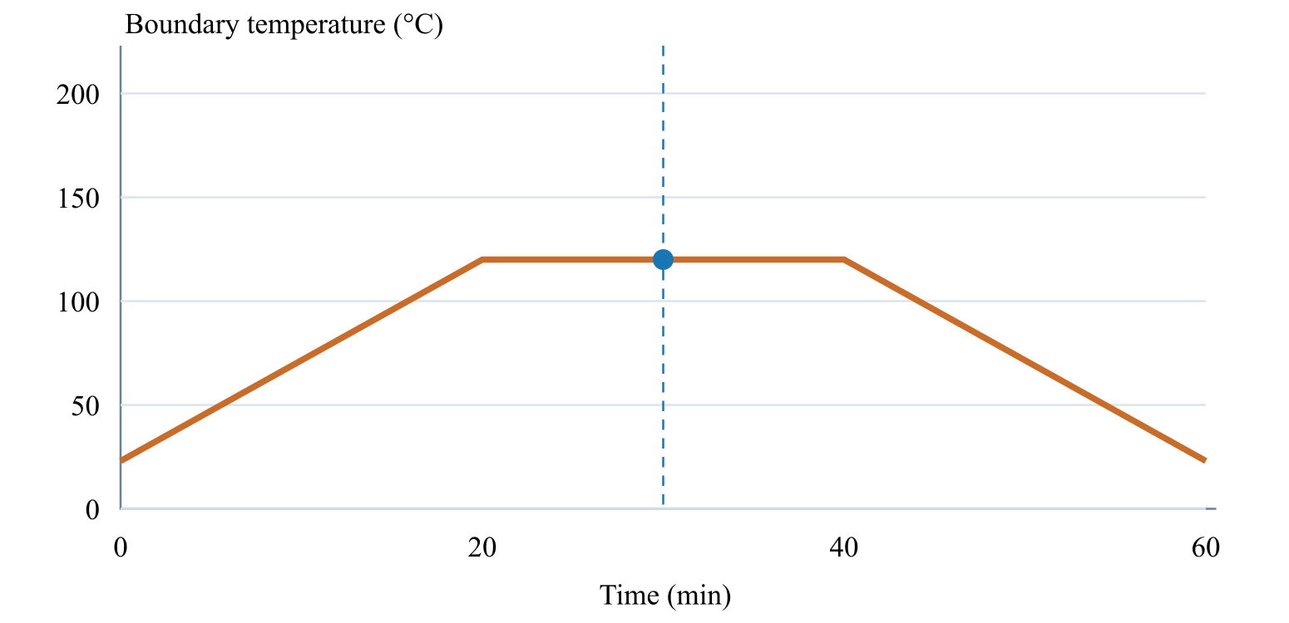
Cursor: 30 min · 300 mm · 120.0 °C
03.4 / Workflow focus
Connected engineering record

Independent boundary schedules
Thermal and moisture loads each need compatible material properties, a laminate, initial conditions and their own surface schedule.

Thermal and moisture formulations
Choose the steady or transient transport model for the study. Transient histories resolve the supported one-dimensional through-thickness problem.

Cure crystallization and UV
Assigned calibrated material laws govern supported polymer-state calculations. UV cure needs its exposure inputs; pultrusion needs the distance/time relationship and pulling speed.

Supported coupling
A process schedule alone is not a solved history. Only compatible coupled analyses consume recovered environmental fields; reference-elastic studies remain separate.

Tool-release shape
The separate free-release CLT study uses prescribed temperatures and effective shrinkage. It is not a tool-contact simulation or an automatic transfer of the thermal cure history.

Process optimization
Compare bounded cycle candidates under supported objectives, save the evidence and rerun the selected candidate.
Workbench availability: released models, inputs and compatible study paths . The wider theory library includes reference formulations not available in every Workbench solve.
Use this workflow in Workbench: interactive Blocks, record selections and connection controls →

Processing released model connections
Expand a family for inputs, outputs, supported formulations, theory and an exercise. All model families
∑ Cure, crystallization & material transport
Models → material-model folders · assigned through Materials
Inputs Calibrated kinetics, modulus or transport laws and material assignment Results / handoff Material laws consumed by compatible Micro or transport calculations
Independent model records can be linked together through material inputs. A saved model must be assigned to a material before it contributes to a simulation.
Formulations and study choices
- Kamal–Sourour autocatalytic
- Kamal–Sourour with diffusion control
- Nth-order Arrhenius
- CHILE (degree of cure)
- UV intensity-dependent cure
- Nakamura–Avrami
- Temperature-dependent tabular
- 1D Fickian diffusion
∑ Theory & assumptions
Guided exercise & two-layer workflow
· Cure kinetics
· Crystallization kinetics
∑ Thermal transport
Models browser → Thermal transport · source: CASES / Thermal
Inputs Laminate transport properties, initial state and the thermal case’s own surface cycle Results / handoff Temperature and supported polymer-state histories; mapped fields only when coupling is enabled
One transport formulation per thermal case. Select its laminate and configure its own initial conditions and surface cycle; pultrusion additionally requires a distance-based die schedule and pulling velocity.
Formulations and study choices
- 1D transient heat transfer
- 1D steady-state heat transfer
- 1D pultrusion thermal cure
∑ Theory & assumptions
Guided exercise & two-layer workflow
· Pultrusion exercise
· UV cure exercise
∑ Moisture transport
Models browser → Moisture transport · source: CASES / Moisture
Inputs Laminate diffusion properties, initial moisture and its own boundary schedule Results / handoff Moisture history and enabled swelling contribution
One formulation per moisture analysis. Thermal and moisture analyses can both be linked in Simulation; each needs its own boundary conditions.
Formulations and study choices
- 1D transient moisture diffusion
- 1D steady-state moisture diffusion
∑ Theory & assumptions
Guided exercise & two-layer workflow
∑ D5229 · Moisture uptake calibration
Models → Structural models → ASTM · Virtual Test Lab
Inputs Linked laminate and explicit specimen, load or measured calibration inputs Results / handoff Homogeneous slab, initially dry, both faces held at equilibrium moisture. Fits diffusivity from two early uptake measurements (both ≤50% saturation) using the square-root-time approximation. Edge ingress and temperature dependence are excluded. Does not overwrite material properties.
Homogeneous slab, initially dry, both faces held at equilibrium moisture. Fits diffusivity from two early uptake measurements (both ≤50% saturation) using the square-root-time approximation. Edge ingress and temperature dependence are excluded. Does not overwrite material properties.
Formulations and study choices
- Virtual test · Fickian uptake calibration
∑ Theory & assumptions
Guided exercise & two-layer workflow
∑ Tool-release shape
Structural models → Tool-release shape
Inputs Laminate and prescribed temperatures, CTE and effective post-gel shrinkage Results / handoff Free-release CLT curvature and separate corner spring-in estimate; not an automatic process-history handoff
Free CLT release from prescribed ply-local shrinkage/thermal eigenstrains. Corner spring-in is a separate uniform-strain estimate. Stress-free temperature and effective post-gel shrinkage need calibration. No tool friction, cure kinetics or viscoelastic restraint history.
Formulations and study choices
- Free-release eigenstrain & spring-in
∑ Theory & assumptions
Guided exercise & two-layer workflow
Next workflow page 03.5 Design →

